Practical Industry in CG Ikhlas SDN BHD

By
LAI CHUN KIT

Dissertation submitted in partial fulfilment of the
requirement for the award of the degree of
Bachelor of Science in Financial Mathematics (with Honours)

FACULTY OF COMPUTER SCIENCE AND MATHEMATICS
UNIVERSITI MALAYSIA TERENGGANU
2026

DISSERTATION CONFIRMATION AND APPROVAL
This is acknowledged and confirmed that the dissertation entitled: Practical Industry in CG Ikhlas SDN BHD by Lai Chun Kit, Matric No: S65947 have been checked and all the suggested corrections have been done. The dissertation is submitted to the Faculty of Computer Science and Mathematics, Universiti Malaysia Terengganu in partial fulfilment of the requirements for the award of the degree of Bachelor of Science in Financial Mathematics with Honours.

Authorized by:

……………………………..  Main Supervisor  Name: Official Stamp: |  | Date: | …………...
……………………………..  Co-Supervisor (If any)  Name:  Official Stamp: |  | Date: | …………...
……………………………..  Practical Industry’s Coordinator  Bachelor of Science in Financial Mathematic with Honours  Name: Puan Siti Madhihah binti Abdul Malik  Official Stamp: |  | Date: | …………...

DECLARATION
I hereby declare that this dissertation is the result of my own research except as cited in the references.

Signature : ……………………………………
Name : Lai Chun Kit
Matric No. : S65947
Date : 20/1/2026

ACKNOWLEDGEMENTS
First and foremost, I would like to express my utmost appreciation towards CG Ikhlas Sdn Bhd (CGI) for offering me the chance to complete my industrial training in this prestigious company. This has been instrumental in closing the loop between what I know academically and how to apply it in a practical sense within data analytics.
I could like to express my heartfelt appreciation to Ms. Elise Chong, who is my industrial supervisor for her guidance, trust and advice during these internship period. I am truly grateful for the freedom she gave me to head knives in high-impact initiatives such as; The Pricing Intelligence Engine (PIE), The Shopee Product Strategy Analyzer, and dozens of custom-built automation data collection tools. She has given me the trust to advocate a move from hand on keyboard data entry to sophisticated & python automation, where my management skills would not be as sharp.
And thank you also to everyone at CGI, especially on the Marketing and Technical sides. I appreciate their openness to take tools I built and diligently incorporate them in their day to day. By using these tools, optimizing for the best efficiency and productivity we were going to take fantastic results from 11.11 Campaign monitoring. Especially, thanks to data-based strategies permitted by these tools, sales significantly have improved from the level of RM70,000 in 2024 to that of RM120,000 in 2025.
An appreciation also to my supervisor from Universiti Malaysia Terengganu (UMT), Dr. Auni Aslah Bin Mat Daud, thanks for your never degree guidance and monitoring towards the writing of this thesis. Special thanks to his comments provided in the site visit, which didn't go unnoticed and have been helpful in terms of framing my project presentations right, allowing me to steered my knowledge in the right directions.
To my family and friends, I couldn’t have done this without your love and support. It's been a life changing job training where I have learned new web scraping, database and system architecture skills which will be invaluable to my future career.

PRACTICAL INDUSTRY IN CG IKHLAS SDN BHD

EXECUTIVE SUMMARY
During my 24-week internship at CG Ikhlas Sdn Bhd, which is widely recognized for its retail brand i-Store and the official platform ihaveit.com.my, I served as a data analyst intern. The company is a prominent Malaysian IT solutions provider and an authorized e-tailer based in Subang Jaya. CGI focuses on the distribution of high-performance computing hardware. It is a certified partner for Asus and the Republic of Gamers. My main objective from August 2025 to January 2026, is modernising the company's retail operations by trying to replace manual and time-consuming processes with data automation and strategic performance tracking tools.
I specifically developing the Shopee and Lazada Product Strategy Analyzers for the 11.11 Mega Campaign. These tools were designed to split up large number of products into actionable strategic groups. The Engagement Remediation section is mainly identified products that attracted high traffic but suffered from low conversion rates. It enabled the marketing team to rapidly identify which listings had issues and rerouted ad spend much more efficiently. Simultaneously, I utilized the Scale Winner section to highlight best-selling products that I had then prioritized for greater ad spend to drive sales volume. As a result of its data driven approach, performance grew rapidly with campaign sales increasing 70% from RM70,000 in 2024 to in excess of RM120,000 in 2025.
After the 11.11 campaign, I moved onto my main project, which was the Price Intelligence Hub. This project began with an experimentation phase in which I built a semi-automated Chrome extension to study how to scrape prices information directly from e-commerce pages. It eventually matured into a full stack automation system, including backend services and a single page web application that integrated the manual review and approval workflow. This hub now serves as the nerve center for operations and gives the company market details so swiftly and accurately that it was previously impossible to achieve manually.
To ensure that the hub sounded smart and reliable when it operated, I built two custom automated collection tools. The first is a seller name collector that is designed to glide right past any security measures and captchas without ever needing a user to log in. With rotating IP VPNs, I protected the system from having seller data missed and I protected the system from being banned by the platform. The second is a price scraper that use to get detailed information on competitors. To protect against unauthorized access to the company's most important accounts, I connected this tool to burner accounts, not official accounts, and then used static VPN IPs. By strategically combining both methods, it enables to maximize data collection while completely eliminating the possibility of our main accounts being frozen/indefinitely banned from the platform.
In summary, this industrial training was an essential link between technical data engineering and organisational impact. I played a key role in the historic growth of the company by developing tools to optimize ad spend through remediation and scaling strategies while growing my professional skill set in Python, SQL, and business intelligence. Through this practical exposure, I have gained the technical expertise and industry knowledge that has prepared me to be a successful data analyst and innovate the company from a manual reporting organisation to an agile, automated, and a high growth organisation.

TABLE OF CONTENTS
DISSERTATION CONFIRMATION AND APPROVAL i
DECLARATION ii
ACKNOWLEDGEMENTS iii
EXECUTIVE SUMMARY v
TABLE OF CONTENTS vii
LIST OF TABLES x
LIST OF FIGURES xi
LIST OF ABBREVIATIONS xvi
LIST OF APPENDICES xix
CHAPTER 1 INTRODUCTION TO THE ORGANIZATION 1
1.1 Introduction 1
1.2 Objectives of Industrial Training 1
1.3 Organization Information 2
1.3.1 Organization Name and Address 2
1.3.2 Organization Background 2
1.3.3 History of the Establishment of the CG Ikhlas SDN BHD 2
1.3.4 Vision, Mission, Motto, Slogan, and Organizational Objectives 3
1.3.5 Organization Logo 4
1.4 Organizational Activities 4
1.4.1 General Management 4
1.4.2 Marketing and Creative Media 4
1.4.3 Finance, Administration, and Human Resources 5
1.4.4 Data Analytics and Business Intelligence 5
1.4.5 Sale Operations (Inside Sales) 5
1.4.6 Business Development (Outside Sales) 6
1.4.7 Inventory, Technical Support, and Logistics 6
1.5 Organizational Chart 7
1.6 Organizational Functions 8
1.7 Location Map and Building Photos 10
CHAPTER 2 MINI PROJECT 13
2.1 Introduction 13
2.2 Project Background and Objectives 14
2.2.1 Project Background 14
2.2.2 Objectives 14
2.2.3 Literature Review 15
2.3 Methodology 17
2.3.1 Phase 1: Data Preparation and Multi-Source Ingestion 19
2.3.2 Phase 2: Strategy Execution (The Formula Engine) 22
2.3.3 Phase 3: Automated Acquisition (The Collectors) 25
2.3.4 Phase 4: Data Processing and Validation Pipeline 28
2.3.5 Phase 5: Analytics & Reporting Ecosystem 31
2.4 Results and Discussion 33
2.4.1 System Deployment & User Interface 33
2.4.2 Comparative Analysis of Operational Efficiency 40
2.4.3 Data Quality and Strategic Value 41
2.4.4 Technical Reliability 43
2.5 Chapter Summary 47
CHAPTER 3 EXPERIENCE AND SKILLS GAINED 48
3.1 Introduction 48
3.2 Experience and Skills Gained 48
3.3 Relation of Work to Theoretical Subjects 50
3.4 Knowledge Learned that Assisted in Industrial Training 52
3.5 Student's Contribution to the Organization 53
3.6 Organization's Contribution to the Student 54
3.7 Communication Networks Established 54
CHAPTER 4 PROBLEMS ENCOUNTERED 56
4.1 Introduction 56
4.2 Skills to be Improved 56
4.3 Communication Skills to be Improved (Technical to Non-Technical) 59
4.4 Operational Challenges & Solutions 61
CHAPTER 5 CONCLUSIONS 63
REFERENCES 65
APPENDIX A: BACKEND ADMINISTRATION & CONFIGURATION 66
APPENDIX B: DATABASE SCHEMA (SYSTEM ARCHITECTURE) 68
APPENDIX C: CORE ALGORITHMIC LOGIC 71
APPENDIX D: RAW DATA SAMPLE (INTELLIGENCE OUTPUT) 73
APPENDIX E: LOG BOOK ACTIVITIES 74
BIODATA OF THE AUTHOR 114

LIST OF TABLES
Table 2-1 Operational Efficiency Comparison 40
Table B-1 Inventory & Strategy Hub 68
Table B-2 Competitive Intelligence Layer 69
Table B-3 Promotion Execution Engine 70

LIST OF FIGURES
Figure 1-1 The i-Store logo, which is widely recognized by customers in Subang Jaya and online shoppers as a symbol of trust and authentic IT hardware. 4
Figure 1-2 Functional Organizational Structure of CG Ikhlas Sdn Bhd 7
Figure 1-3 Organizational Chart of CG Ikhlas Sdn Bhd 7
Figure 1-4 Chart Location Office CG Ikhlas SDN BHD 10
Figure 1-5 The showroom of CGI 10
Figure 1-6 The front building view of CG Ikhlas SDN BHD 11
Figure 1-7 The office front door entry view of marketing department 11
Figure 1-8 The office view of marketing department 12
Figure 2-1 Price Intelligence Hub V3 System Architecture. This shows the complete 5-phase Data Pipeline flow transition in which all critical steps are completed for every stage of activity ends successfully, from Data Preparation (Phase 1) and Strategy Execution (Phase 2) done in Administrator Workspace through to Automated Acquisition agents (Phase 3) and Validation Pipelines (Phase 4)--via the final Analytics & Reporting Dashboard (Phase 5) used by staff even when all resources have been redistributed. 18
Figure 2-2 Phase 1 – Data Preparation and Multi-Source Ingestion. The workflow for ingesting raw inventory and promotion data from heterogeneous sources (Excel, CSV). The diagram shows the staging logic including the "Inventory Sync Widget" for upserting records and the "Archival Process" (Maintenance Job) that automatically migrates expired promotions to historical storage to maintain database performance. 19
Figure 2-3 Phase 2 – Strategy Execution (The Formula Engine). This diagram illustrates the core "7-Step Macro Pipeline" within the Master Workbook that transforms raw inventory into a standardized "PIE_FEED." It also details the auxiliary Maintenance Tools (Audit, Repair, Formatting) used to ensure data integrity, and the Archival Process that migrates historical strategy feeds and candidate data to long-term storage tables (pie_feed_history, cgi_candidates_history). 22
Figure 2-4 Phase 3 – Automated Data Acquisition Logic. The chart showed decision tree and behavioral logic for the scraping bots (Competitor and Seller Collectors). The flow showed details like the "Human-Like Interaction" sequences, including the "Search-Type-Enter" simulation, random scroll intervals for captive detection, and the conditional handling of CAPTCHA challenges during data capture. 25
Figure 2-5 Phase 4 – Data Processing & Validation Pipeline. This diagram illustrates a full transformation pipeline. The raw captured data is passed through a strict three-stage validation process before storage. The "Competitor Validation Pipeline will sequentially applies a "Self-Exclusion Check" to remove internal company product’s listings, then "Heuristic Matching Engine" calculates similarity scores based on token and sequence logic, and a "Hardware Spec Guard" to validate RAM/storage patterns. Additionally, the workflow demonstrates the "Seller Validation Pipeline", where new seller metadata is captured via a passive extension listener. Then, it will be queued for administrative approval before being committed to the sellers database table. 28
Figure 2-6 Phase 5 – Analytics & Reporting Ecosystem. This chart illustrates the comprehensive analytics architecture. It organized into three distinct operational part, Single Analysis, Bulk Analysis, and Promotion Dashboard. 31
Figure 2-7 Price Intelligence Hub Main Dashboard. The interface integrates the Admin Notice Board, Quick Stats Grid, and Activity Feed into a single operational view. 34
Figure 2-8a Single Analysis & Competitor Context Interface. Notice how the internal "Product Card" (Top) is shown next to a ranked list of "Competitor Matches" (Bottom). 35
Figure 2-8b Integrated Interpretation Guide. This overlay specifies heuristic logic for consideration in Match Confidence and on Price Gap analysis. 35
Figure 2-9 Bulk Analysis Configuration Panel. Key controls include the Analysis Scope selectors, Matching Level slider, and Detail Export toggle. 36
Figure 2-10a Internal Campaign Timeline (Macro View). The Gantt chart visualizes the duration and overlap of internal sales events. 37
Figure 2-10b Portfolio Distribution. This section distribute the active campaigns by Brand and Category. 38
Figure 2-10c SKU Level Calibration & Export (Micro View). It consists detailed list of products within a specific campaign, which ready for validation export. 38
Figure 2-11 Automated Pricing Strategy Report (Excel). See how "status logic" and seed (comments) are used to generate the seller's metadata. 39
Figure 2-12 Price Analysis Gallery. This is an offline, available-at-all-times record of the price analysis. 40
Figure 2-13 Heuristic Logic Validation (Terminal View). Notice that Step 2.5 - Spec Validation is logged to the console, indicating that competitors with a low text score are kept as long as they meet the technical specs. 42
Figure 2-14a Seller Collector Dashboard. It the high-volume processing queue (Left) and the "Pending Approvals" staging area (Right), which is where captured metadata allows analysts to resolve hundreds of unknown Shop IDs per hour………………………………………………………………………...44
Figure 2-14b Passive Capture Event. The green toast notification confirms that the background listener found and extracted seller identity data (Little Orange Shop show in this figure) as soon as the page loaded without any manual action from the user. 44
Figure 2-15a Human Input Simulation. The browser console show the "Typing Algorithm", where the system injects keystrokes at random, human-like intervals that are simulate human thought. 45
Figure 2-15b Adaptive Scroll Logic. The "Plunge-and-Retreat" scroll pattern is applied to trigger AJAX load for stock level capture to be deep without activating the "Fast-Scroll" bot detector. 46
Figure A.1 Search Phase Pattern Injection. The terminal echo output illustrates the "Query Aggregator" engine, which injects its own custom regex patterns (such as ^8GB. *SSD$) to the market search engine and generate the Refined Candidate List. 66
Figure A.2 Operational Batch Configuration. The main interface for configuring the range of daily export. The key features include: 1) Smart Strategy Whether to process Stale records only (>7 days old and so on), 'Force Scrape' or not; 2) Target Filters: narrow down the list for those high-priority Products on Brands or Categories (for example, "Asus" + "Laptop"); and then 3) Queue Preview which is similar to doubles-checking with a pre-flight calculator showing an estimate of how long this specific job would take at the click of a button. …………………………………………………………………………67
Figure A.3 Multi-Layered Filtering Engine. The proposed system applies a three-level validation pipeline to reduce false positives: (a) Brand Whitelisting: Narrow the search space for known entities, such as ["Asus", "Dell"], to remove brand-generic knock-offs. (b) Taxonomy Levels): Relates categories with Risk-Levels that would usually be more specific (e.g., "Strict" for monitors vs. "Relaxed" for cables). (c) Advanced Fine Tuning: exposes the logic to see the "Glass Box", allows Regex pattern injection and tweak thresholds (default 0.85) for edge cases. 67
Figure C.1 Implementation of the Stochastic Human Mimicry Protocol, utilizing randomized delays and micro-interactions $δt$ to evade behavioral bot detection. ………………………………………………………………………………….71
Figure C.2 The Heuristic Similarity Algorithm, demonstrating the weighted fusion of Token Overlap (Jaccard) and Sequence Matching logic for candidate scoring. ………………………………………………………………………71
Figure C.3 The Specification "Guard" Logic, acting as a deterministic filter to reject hardware mismatches (e.g., RAM capacity) regardless of title similarity. ………………………………………………………………………………….72
Figure D.1 Live Intelligence Snapshot (JSON) captured from the Production Worker module, showing successful competitor price extraction. 73

LIST OF ABBREVIATIONS
Abbreviations
AJAX | Asynchronous JavaScript and XML
API | Application Programming Interface
B2B | Business-to-Business
B2C | Business-to-Consumer
BAU | Business as Usual
CGI | CG Ikhlas Sdn Bhd
CI | Competitive Intelligence
COM | Component Object Model
CPC | Cost Per Click
CSS | Cascading Style Sheets
CTR | Click-Through Rate
DAX | Data Analysis Expressions
DOM | Document Object Model
DSS | Decision Support System
ERP | Enterprise Resource Planning
FK | Foreign Key
GPU | Graphics Processing Unit
HTML | HyperText Markup Language
IO | Internal Order
IT | Information Technology
JS | JavaScript
JSON | JavaScript Object Notation
PIE | Pricing Intelligence Engine
PO | Purchase Order
POE | Proof of Execution
RAM | Random Access Memory
RMA | Return Merchandise Authorization
ROAS | Return on Ad Spend
ROG | Republic of Gamers
RRP | Recommended Retail Price
SDLC | Software Development Life Cycle
SKU | Stock-Keeping Unit
SME | Small and Medium-sized Enterprise
SOA | Service-Oriented Architecture
SQL | Structured Query Language
SSD | Solid State Drive
UI | User Interface
UMT | Universiti Malaysia Terengganu
WAF | Web Application Firewall
YOY | Year-over-Year

LIST OF APPENDICES

APPENDIX A: BACKEND ADMINISTRATION & CONFIGURATION 66
APPENDIX B: DATABASE SCHEMA (SYSTEM ARCHITECTURE) 68
APPENDIX C: CORE ALGORITHMIC LOGIC 71
APPENDIX D: RAW DATA SAMPLE (INTELLIGENCE OUTPUT) 73
APPENDIX E: LOG BOOK ACTIVITIES 74

INTRODUCTION TO THE ORGANIZATION
- Introduction
This chapter gives a review of the company where industrial training was taken at namely CG Ikhlas Sdn Bhd (CGI). It covers the goals of the industrial training, a description of the company profile and history background (company organizational structure such as vision, mission & objective), organisation chart and its departments core functions.
- Objectives of Industrial Training
Industrial training is an obligatory part of the academic syllabus for the purpose to provide students with their initial realization on how they can work in industry.
The aims of this programme are:
- To provide students with industrial exposure by learning to work in a fast-paced e-commerce and Information Technology (IT) environment.
- To use theoretical insights, especially in data analysis, programming and statistics to solve business problems.
- To establish and maintain professional connections with industry professionals for future career opportunities.
- To develop technical hard skills in Python programming, Excel, SQL database management and applied mathematics, alongside fundamental soft skills in communication and complex problem solving.
- Organization Information
    - Organization Name and Address
Name: CG Ikhlas Sdn Bhd
Address: No 34 & 36, Jalan Industri USJ 1/11, Taman Perindustrian Usj 1, 47600 Subang Jaya, Selangor
    - Organization Background
CG Ikhlas Sdn Bhd (CGI) is a reputable company in Malaysian IT retail market, which is widely recognized by the public through its store-based retailer, i-Store and an extensive online portal, ihaveit. com. my. Tucked centrally in the heart of Subang Jaya, the company is a go-to store for consumers, gamers and enthusiasts who are looking for highend computing hardware.
To the client, CGI is the "One-Stop IT Hub" giving that peace of mind. The shop is a Multi-Brand Authorized Dealer, so it retails authentic products from worldwide tech leaders. Though they’re best known as a Gold Partner for ASUS and Republic of Gamers (ROG), their product list also includes full ranges from Lenovo, MSI, HP, Dell, Cooler Master and etc. Whether you’re that customer who stops by the showroom to play around with a gaming laptop or someone who’s ordering components via its website, its official manufacturer warranties ensure you get the best shopping experience.
    - History of the Establishment of the CG Ikhlas SDN BHD
CGI was created in response to an important gap in the market, namely that for a reliable reseller of IT equipment from whom customers could purchase genuine hardware with confidence as opposed to grey imports or counterfeit products. From a small IT store in Subang Jaya, it has now evolved into a full-fledged omnichannel retailer.
The company expanded beyond that physical shop over the years to follow a need for shopping online. It has a strong online presence today with well-rated official stores on Shopee and Lazada, alongside its own website. That progression has enabled the company to serve customers across the country, online with the same knowledge and diverse array of products that they would find in any one of its showrooms.
    - Vision, Mission, Motto, Slogan, and Organizational Objectives
- Vision
To become the preferred technology destination for Malaysian consumers, synonymous with quality, variety and customer service excellence.
- Mission
- Deliver confidence to customers that all product sold is 100% authentic and will come with the local warranty.
- Provide a higher level of shopping experience by proactively establishing technical service, fast logistics and thoughtful after-sales service.
- To deliver the newest technology at a price that’s competitive with other outlets, while offering a variety of ways to shop.
- Objective
- To provide the widest variety of IT hardware on the market for an average customer to easily be able to find everything they need from gaming laptops in one place, all the way down to office equipment.
- Keep up the good work when it comes to positive customer satisfaction score on platforms like Shopee, Lazada, Tiktok.
- Consolidate relationship with brand principles (such as ASUS & Lenovo), due to which customer gets the 1st priority on new product launches and exclusive offers.

    - Organization Logo

Figure 1-1 The i-Store logo, which is widely recognized by customers in Subang Jaya and online shoppers as a symbol of trust and authentic IT hardware.
- Organizational Activities
A SME with main business in ecommerce, CG Ikhlas Sdn Bhd is running a light and flexible management style. While the business does maintain a showroom, it acts primarily as fulfillment center and not in the traditional retail sense. This means that their day to day is focused around everything from e-commerce and logistics, to backend support. With the fast-moving environment of the business, functional responsibilities do indeed overlap and hence close interdisciplinary relationship between the following core departments is essential:
- General Management
The management of the organization is based on General Management that has the strategic and directional control. This department is responsible for the maintenance of relationship senior with brand principals (e.g. ASUS, LENOVO) as well as setting long term business targets that provides guiding light to all other functions.
- Marketing and Creative Media
The strategic center of the company’s B2C business, as online retailer takes place in the Marketing and Creative Media department. The latter department plans the campaign calendar around high-traffic e-commerce events, like Payday Sales and monthly “double-date” days. Importantly, this unit also partners with the Graphic Design sub-unit. All promotional banners, product assets, and store decor to push higher CTR (click through rate) & conversions within digital store fronts are created from this team.
- Finance, Administration, and Human Resources
Headcount department provides organizational framework, structural solidity, and financial transparency. One is the administrative and accounting functions, which includes the strict verification of bills and auditing of transactions, particularly the margins within the competitive IT sector. At the same time, the Human Resources function is managing workforce planning and recruitment to ensure the operational capacity of the company can grow in line with the spikes in labour demand generated by peak sales periods.
- Data Analytics and Business Intelligence
Data Analytics and Business Intelligence unit served as the modernization arm of the organization. This unit primarily focuses on converting manual workflows into automated, data-driven processes. This unit serves as the "Decision Support System"(DSS) for the Marketing team to spend more on Ads and Management to make pricing decisions on-the-fly by interpreting large-scale market data and pricing trends of competitive brands.
- Sale Operations (Inside Sales)
Sale Operations unit is the first line of contact for digital retail outlets on platforms like Shopee and Lazada. On this team, they mainly monitor and verify incoming online orders and stock in real-time. The idea is to validate whether or not a digital transaction can fulfil against physical inventory levels, before the fulfillment of the transaction, in order to generating accurate seller ratings and reducing order cancellations.
- Business Development (Outside Sales)
Unique from the internal advertising evaluate, the Business Development and Outside Sales unit pursues B2B (Business-to-Business) expansion and corporate sales. This department handles all the tedious transactional governance of large-scale transactions and processing of IO (Internal Order) and PO (Purchase Order). The distinction lets the firm target extended company contracts without interfering with the daily e-commerce business cycle.
- Inventory, Technical Support, and Logistics
This department oversees the entire physical product lifecycle and "last-mile" execution. The Inventory and Technical Support sub-unit is responsible for replenishing stocks and offers value-added services like hardware upgrades (i.e., RAM/SSD installations) and system troubleshooting. The Logistics and Fulfillment team did all the heavy lifting of secure focused pick, pack and ship. This unit also takes care of warehouse arrivals for incoming supplier shipments, ensuring that bigger stocks are arranged in a required table whilst synced to the digital inventory.

- Organizational Chart
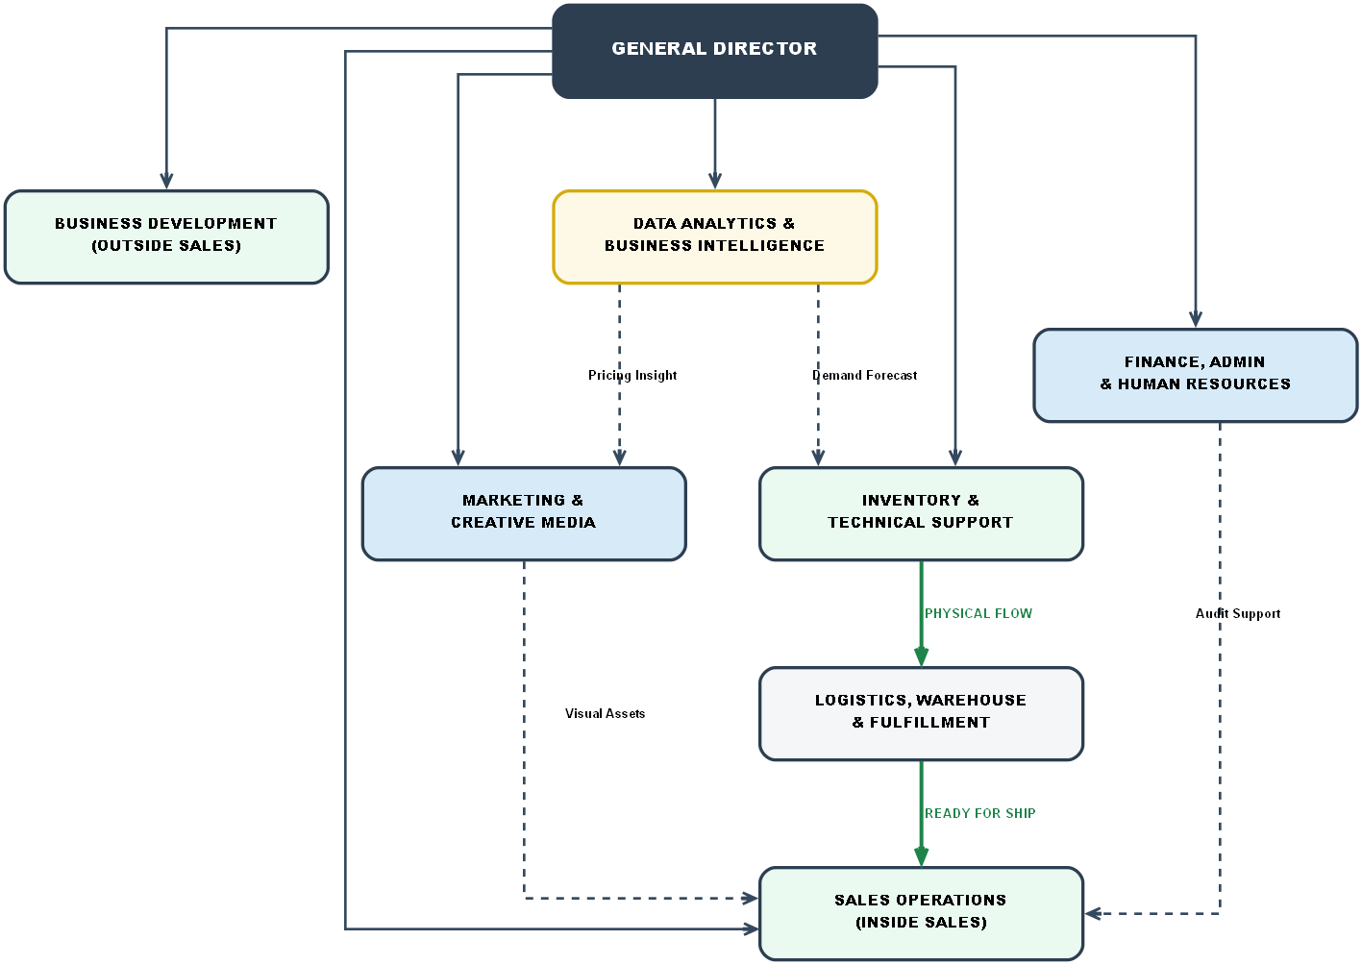
Figure 1-2 Functional Organizational Structure of CG Ikhlas Sdn Bhd

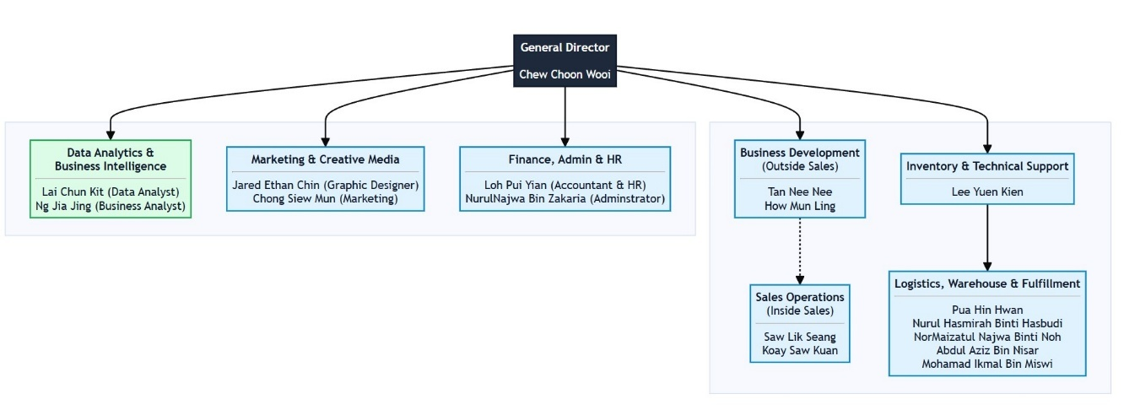
Figure 1-3 Organizational Chart of CG Ikhlas Sdn Bhd

- Organizational Functions
Being one of the forefronts of the Malaysian digital economy, CG Ikhlas Sdn Bhd has multiple essential services that connects international tech firms with end-users:
- Authorized distribution channel
The organisation acts as a gateway to Principals around the world including ASUS, Lenovo and MSI. This is not to prevent imports as such, it is more to ensure a genuine and non-unauthorized hardware is available in the Malaysian markets. All the products are sourced from OEM (original equipment manufacturer) channels to assure quality which is the leading cause of concern while purchasing products online.
- E-Commerce Fulfillment Hub
The organisation is a digital retail fulfilment centre of great volume. It handles the entire lifecycle of orders made online from Shopee, Lazada and its own website. Such services entails maintaining stock, secure packing and logistics for immediate delivery to customers nationwide.
- Technical Value Add
Unlike"box-move" resellers, CGI is a technical service provider. The company distinguishes itself by providing pre-delivery customization (upgrades to RAM and SSD, for example) while acting as an intermediary for warranty claims (RMA). And this feature allows users to get the hardware best suited for them right out of the box.
- Market Intelligence and Pricing Strategy
Following the implementation of business intelligent systems, the company itself is a data-driven organisation. It constantly tracks market trends and competitor prices to maintain dynamic pricing strategies. It is this function through which the company lead the market by being a price leader and ensuring profit at an operational level.

- Location Map and Building Photos
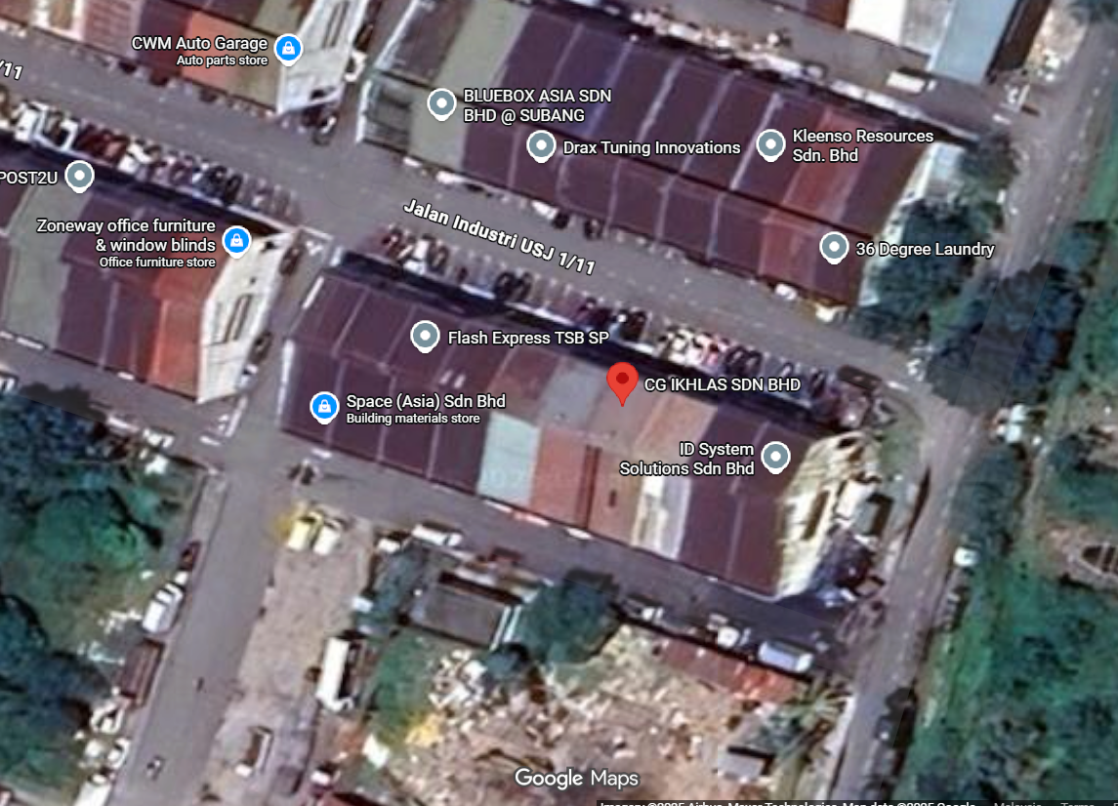
Figure 1-4 Chart Location Office CG Ikhlas SDN BHD
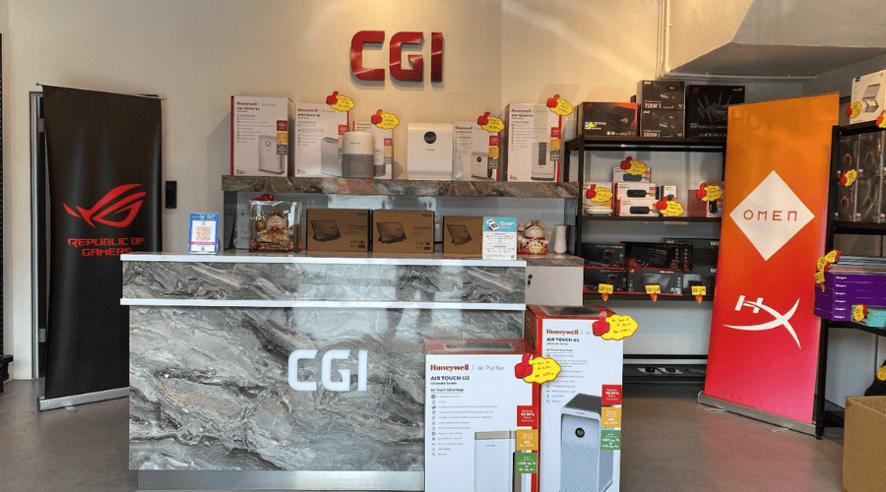
Figure 1-5 The showroom of CGI
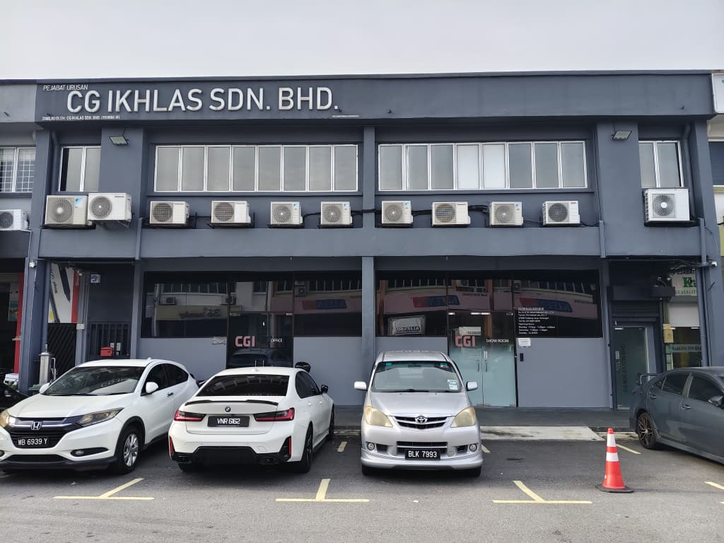
Figure 1-6 The front building view of CG Ikhlas SDN BHD
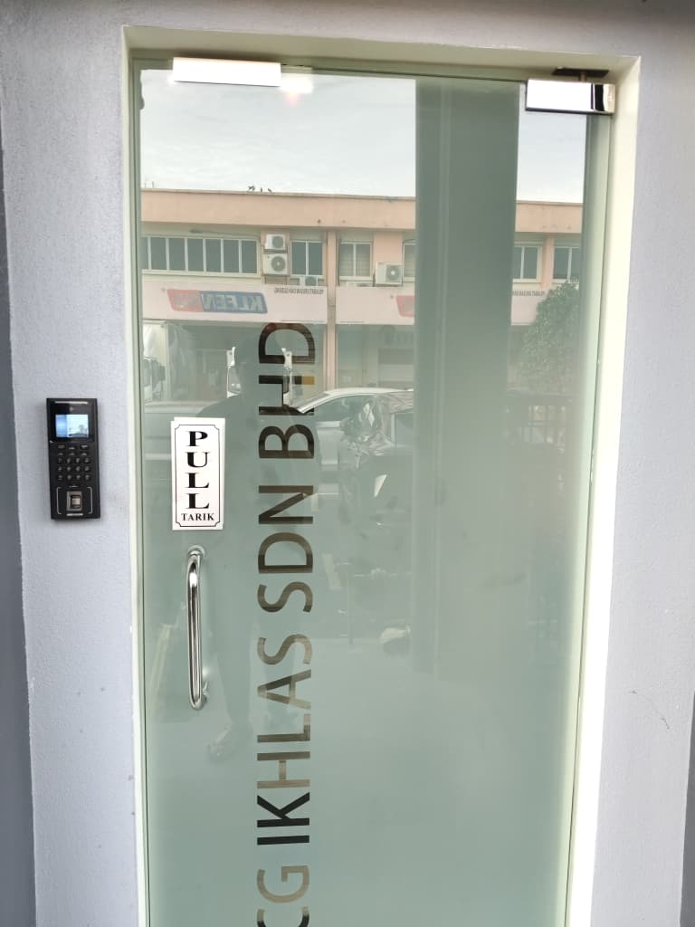
Figure 1-7 The office front door entry view of marketing department
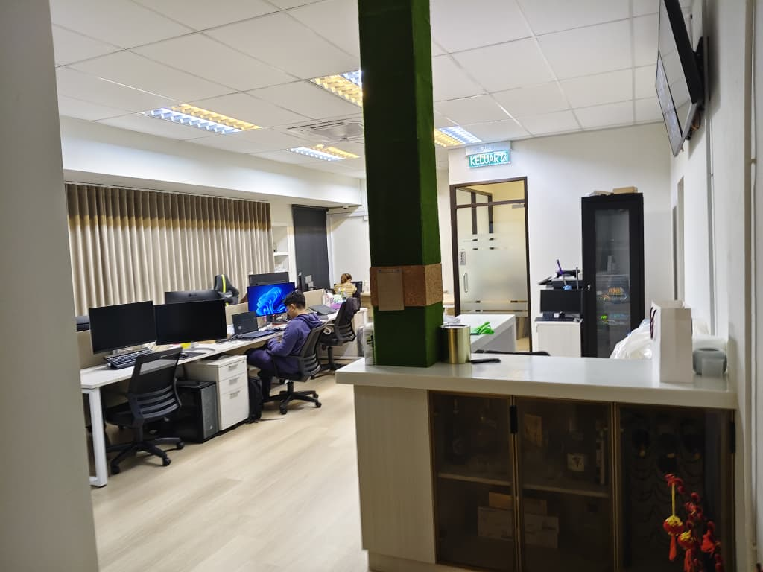
Figure 1-8 The office view of marketing department

MINI PROJECT

- Introduction
Chapter 2 provides a detailed technical exposition of the Price Intelligence Hub V3, a system developed to serve as the primary source of truth for market intelligence and competitive pricing. The project was conceptualized to modernize traditional retail operations by transitioning from labor-intensive manual competitor monitoring to a fully automated data acquisition framework. However, as the company grew and its product catalogue increased, the volume and complexity of the work became too much for the previous manual workflows, creating a need for an efficient digital solution that could scale and offer market intelligence within a report’s turnaround time.
In order to maximize performance and maintainabilty, the system is built using a Service-Oriented Architecture (SOA) via a loosely coupled Controller-Worker design pattern. It combines four basic functional pillars; the Web Controller that handles session management and serving the UI, the Collector Engine that handles automated data scraping, the strategy engine that handles automated Excel sync over the COM interface, and the Intelligence Engine that handles data normalization using Machine Learning. With the introduction of Price Intelligence Hub V3, these components are centralized to provide the organization with a quick market view and a differentiated competitive edge that was not possible with manual processes. The upcoming sections describe the technical approach, the specific "Stealth Scraping" algorithms used and the overall results seen as a consequence of the system.
- Project Background and Objectives
- Project Background
Leading up to the build of Price Intelligence Hub V3, CG Ikhlas Sdn Bhd struggled with operational hurdles that impact on competing for pricing across their e-commerce platforms. With a wide range of products spanning in thousands of Stock-Keeping Units (SKUs) on the marketplaces like Shopee, Lazada this current workflow was manual competitor tracking intensive. This manual process was not only time consuming and tedious, but errors were made by human hands and “blind spots” occurred where the company did not actually realize it was pricing its product higher than competitors in the market.
And there was no real-time data, so pricing actions were more reactive. The marketing team would often price large campaigns on gut feel or outdated reports, so the company was leaving money and profit margin by chance. To address these inefficiencies the firm required a unified, automated system capable of capturing, analyzing and reporting on market data quickly and accurately. That requirement inspired the creation of a custom “Price Intelligence Hub” that serves as the single source of truth for pricing decisions.
- Objectives
The project’s destination was to revolutionise the company’s retail by innovation. The specific objectives were:
- To create a "headless" automated data collector engine, which would continuously scrape high volume pricing data from competitors' store thereby doing away with the cumbersome manual entering of Pricing Data.
- To develop a complete human imitation layer to implement the "Ghost Mouse" protocol, naturalized keystroke dynamics and heuristic scrolling patterns, in order to effectively bypass behavioral biometric security mechanisms.
- To develop a live scoring engine in Excel through COM interfaces, bringing the technical database closer to the way marketing staff work and making it possible for non-technical users to make data-driven decisions.
- To create a real-time, graphic representation of market positioning and “Trust Tiers” in a single intelligence dashboard for instant recognition and correction of competitive pricing gaps.
- Literature Review
The evolution of the Price Intelligence Hub V3 has been built on academic research, and industry-dominant concepts of data mining, IT security and strategic market placement. In formal terms, Web scraping is an automated software technique to extract large amounts of information from websites and then convert it into a structured data for business analysis purposes. According to Glez-Peña et al. (2014), the effectiveness of information retrieval in contemporary e-commerce heavily relies on a system’s capability to handle and parse complex DOMs. Since modern platforms like Shopee heavily rely on JavaScript dynamics, testing and automation frameworks such as Selenium are required to obtain live pricing information that conventional static scrapers cannot retrieve.
Such systems’ architectural robustness is typically tackled from the perspective of software engineering patterns. Ferrara et al. (2014) claim that web information extraction has become one of those changing forms, and its technologies involve the development of solid methodological tools to address the heterogeneity of web sources and usually follows decoupled architectures to guarantee scalability. The Price Intelligence Hub V3 removes the data acquisition “worker” from the central web controller in a Service-Oriented Architecture (SOA) allowing for significant numbers of concurrent SKU requests to be executed without suffering any system degradation. This is so that we can keep the inflow of data steady even during times of heavy platform traffic, and continue to have a live view into competitive landscape for the company.
The argument of strategic positioning on the marketplace is empowered by Competitive Intelligence (CI) theory that defined it as a set of methods and techniques for an ethical and systematic information gathering and processing about competitor activities, in the service of reaching competitive advantages. According to Bose (2008) CI acts as a strategic weapon of intelligence analysis that would enable companies to spot market changes and competitors’ threats earlier than they do it on financial record. Automating the acquisition of public market data, the company is able to turn external environmental signals into proprietary internal intelligence which enables its members to be more timely and informed when making business decisions in digital marketplace nowadays.
Dynamic pricing — where the prices of products are adjusted in real time based on market demand and competitive positioning — is considered a matter of survival in cutthroat e-commerce. Kannan and Kopalle (2001) observe that the capability of companies to watch for and respond almost immediately in price changes through the internet implies that consumers should not automatically expect to receive a consumer surplus. Specifically, the Strategy Engine we built in helps to enact some of these theories by providing pricing updates at the SKU level and enabling "Trust Tiers" where you don’t even have to look at all of your SKUs but can be at a competitive state.
While e-commerce websites continue to improve bot-detection technology, behavioral biometrics are emerging as a key enabler for stealth data acquisition. Feher et al. (2012) show that bots can be detected and differentiated from human users organically by analyzing mouse dynamics, especially movement trace, velocity and clicks. To alleviate this, the project leverages a human emulation layer through "Ghost Mouse" algorithm. This algorithm uses non-linear Cubic Bezier curves to simulate the jitter and acceleration of a human hand. Additionally, the system replicates naturalized keystroke behavior of random latent input characters and heuristic scrolling muscle memory logic to emulate human reading habits which can effectively evade behavior based security measures such as CAPTCHA.
An important technical bottleneck in market monitoring is entity resolution; ie, correctly determining which disparate text strings by different sellers correspond to the same physical good. Getoor and Machanavajjhala (2012) claim that heuristics-based matching systems are required for ensuring database integrity and fighting duplicates in massive databases with the use of brand filtering and specification validation. The system’s Four-Tier Matching Logic filters out unrelated competitor listings, or what it calls "false positive" matches which often occur with simpler keyword-based search algorithms.
Finally, for SMEs, the process of moving from intuition to data-driven decisions is a necessity in the long run if it has any hope of becoming competitive. Turban et al. (2014) consider Decision Support Systems (DSS) as automated systems supporting managers in solving semi-structured problems by making available analytical models and data. This trend is facilitated by the Resource-Based View (RBV) of the firm, in which Barney (1991) suggests that a technology held to be valuable, rare and non-imitable can lead to sustained competitive advantage. With the use of a Python intelligence backend combined with an Excel COM interface, The Price Intelligence Hub is effectively a DSS which will provide an organization with their own unique power-user resource.
- Methodology
The implementation and live operation of the Price Intelligence Hub V3 which is shown in the Figure 2-1 is based on an extensive five phase technical pipeline connecting manual e-commerce administration work-flows with high-volume automated business intelligence. This process follows the full lifecycle of data, from ingestion and staging with multiple sources through to a complicated Excel-based strategy engine to fully automated market acquisition and trust-weighted analytic reporting.
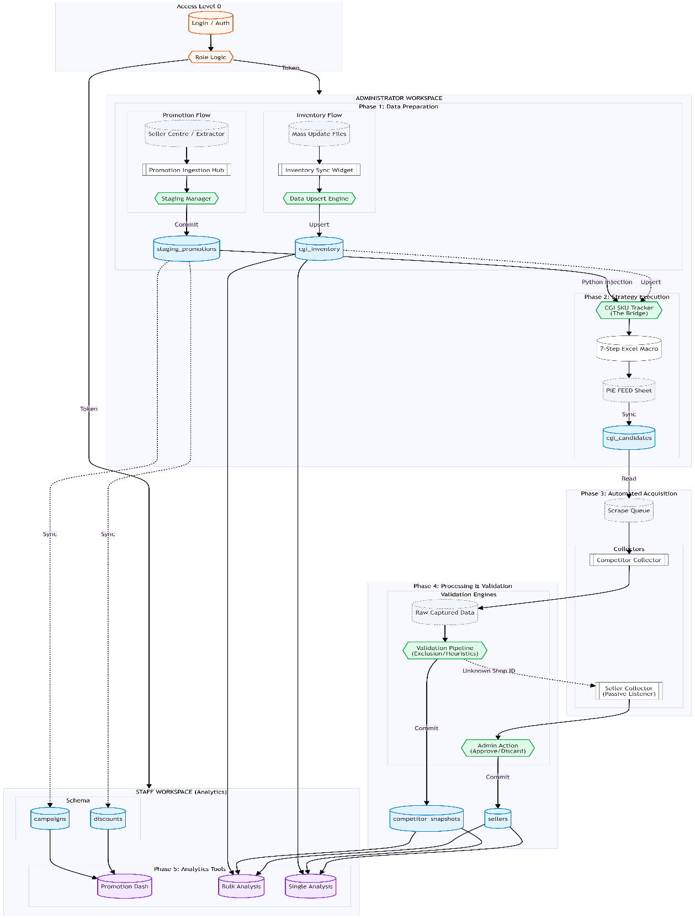
Figure 2-1 Price Intelligence Hub V3 System Architecture. This shows the complete 5-phase Data Pipeline flow transition in which all critical steps are completed for every stage of activity ends successfully, from Data Preparation (Phase 1) and Strategy Execution (Phase 2) done in Administrator Workspace through to Automated Acquisition agents (Phase 3) and Validation Pipelines (Phase 4)--via the final Analytics & Reporting Dashboard (Phase 5) used by staff even when all resources have been redistributed.
- Phase 1: Data Preparation and Multi-Source Ingestion
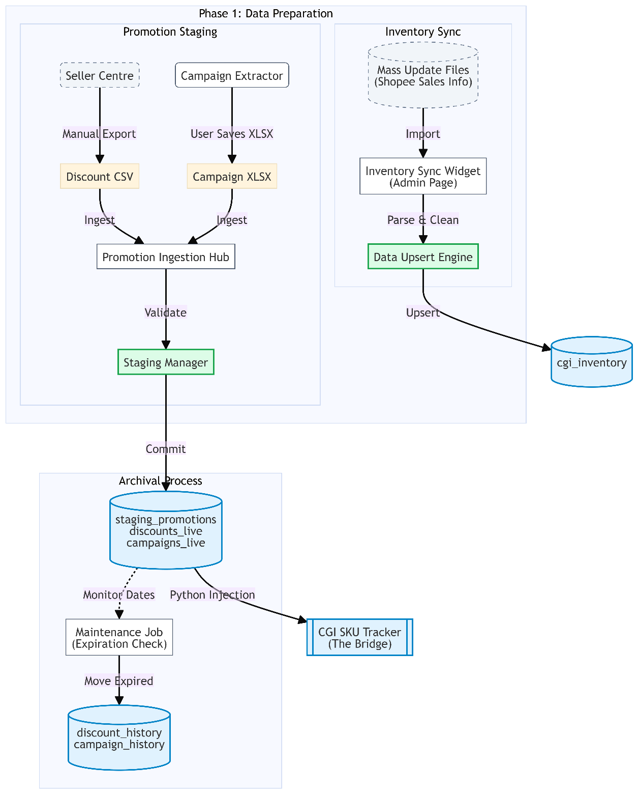
Figure 2-2 Phase 1 – Data Preparation and Multi-Source Ingestion. The workflow for ingesting raw inventory and promotion data from heterogeneous sources (Excel, CSV). The diagram shows the staging logic including the "Inventory Sync Widget" for upserting records and the "Archival Process" (Maintenance Job) that automatically migrates expired promotions to historical storage to maintain database performance.
The foundational stage of the methodology, shown in Figure 2-2, is about linking those records that dwell inside the system with information out in the volatile marketplace. Instead of forcing analysts to spend precious time and energy on manual data fetching and data cleansing, this phase electrically generates two separate input data streams: basic inventory folder and real-time multi-platform promotional inputs.
- Inventory Synchronization and Database Upsert
Step one is to manually download the Mass Update Sales Info files (Parts 1 and 2) from the Shopee Seller Centre. The data is then imported into Structured Reports via an Inventory Sync Widget on the administrator dashboard, which uses a powerful Data Upsert Engine to interface with a live system. This engine carries out a UPSERT operation (Update-if-exists, Insert-if-new) on the cgi_inventory table in the database, so that critical fields like stock levels, listing prices, and SKU status are refreshed. At the same time, the system carries out a Python-driven injection to push this new data into the Stock_List sheets of the master Excel workbooks, thereby bypassing manual data entry and ensuring consistency across all platforms.
- Multi-Stream Promotion Ingestion
To accommodate the complexity of e-commerce digital retail marketing, for this first release (Phase 1) a split-source ingestion logic is used to ingest promotional data:
- Discount Promotions: Regular seller promotion discounts are manually exported as CSV from the Seller Centre and saved in a dedicated local directory.
- Campaign Promotions: High frequency episodic events, e.g., 11.11, 12.12 are captured through a custom Campaign Extractor Extension. This extension scrapes unstructured campaign data and returns it into the browser DOM, validating against excel sheet.

- The Promotion Staging Hub and Validation Gate
Both promotional streams are funneled into the Promotion Ingestion Hub, where undergo a mandatory validation process within a "Staging Area" (staging_promotions table). This staging layer serves as a quality control gate where the administrator reviews file integrity, price formats, and promotion timelines, specifically the Start and End dates, before the data is committed to the live environment. Once verified, a "Commit" trigger moves the data into the discounts_live and campaigns_live tables, while an automated maintenance job monitors these records to archive expired entries into historical tables for future auditing.
- Operational Loop Closure: The Data Bridge
The final technical operation of Phase 1 is the CGI SKU Tracker (Discount & Campaign).xlsx. The system will using a specialized Python injection script to extract the validated records from the live promotion tables and populates this "Bridge" file. This SKU tracker later on will be acting as the centralized artifact of Phase 1, and push to the structured data source that the Price Comparison.xlsm workbook via Power Query to calculate final strategic prices in the subsequent methodology phases.

- Phase 2: Strategy Execution (The Formula Engine)
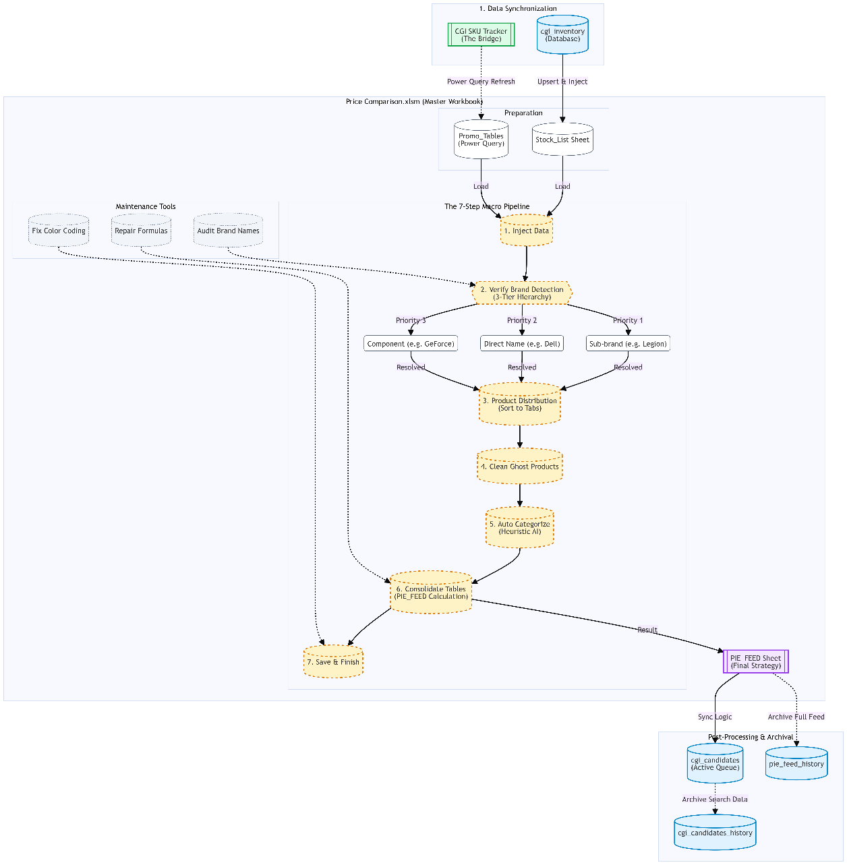
Figure 2-3 Phase 2 – Strategy Execution (The Formula Engine). This diagram illustrates the core "7-Step Macro Pipeline" within the Master Workbook that transforms raw inventory into a standardized "PIE_FEED." It also details the auxiliary Maintenance Tools (Audit, Repair, Formatting) used to ensure data integrity, and the Archival Process that migrates historical strategy feeds and candidate data to long-term storage tables (pie_feed_history, cgi_candidates_history).
The second phase of the methodology as sketched in Figure 2-3 transitions from raw data ingestion to the execution of the system’s core strategic logic within the Price Comparison.xlsm master workbook. This phase serves as an advanced "Formula Engine," designed to synthesize internal inventory levels, active promotional campaigns, and historical market data into a finalized pricing strategy.
It starts with critical Data Synchronization process to set up the Excel environment. Initially, the system performs an Inventory Refresh that upserted current records from the cgi_inventory database and injected into the workbook’s Stock_List sheet. At the same time, a Power Query Refresh is triggered to pull the latest campaign and discount data from the CGI SKU Tracker (The Bridge) into local Promo_Tables. To ensure the integrity of the workbook before processing, the methodology incorporates a set of Maintenance Tools which enables the administrator to audit brand names, correct broken formulas and rectify conditional colour coding rules.
After the system is trained, it runs through the 7-Step Macro Pipeline, which is a linear sequence of automations that turn the imported data into insights that can use:
- Inject Data: The initial master data sheets are filled with the consolidated inventory and promotion data in sync.
- Verify Brand Detection: The system uses a 3-Tier Hierarchy logic to resolve brand mapping. It mainly looks for Sub-brands (e.g., auto-mapping "Legion" to Lenovo) , then it checking for Direct Names (e.g., Dell) and finally falling back to Generic Components (e.g., GeForce).
- Product Distribution: Products are automatically separated and designated into individual brand controlled tabs for more zoomed in to review.
- Clean Ghost Products: The dataset is cleaned of zero-stock products and listings that are no longer active in the marketplace.
- Auto Categorize: Using heuristics AI & regex patterns to automatically categorize tech categories (Laptops, Monitors, etc.) for new products that are un-classified.
- Consolidate Tables: Finalized pricing formulas available in the master PIE_FEED Sheet for all the brand-specific insights are combined into one. Strategic target prices are calculated accordingly.
- Save & Finish: The workbook state is finalized and saved for archival.
This phase included post-processing and archival before passed to the automated collector. The resulting target product from the PIE_FEED are copied into the cgi_candidates active queue through a sync logic. At the same time, it initiating an archival snapshots of them from full feed into pie_feed_history and search data into cgi_candidates_history for long-term back track as needed.
- Phase 3: Automated Acquisition (The Collectors)
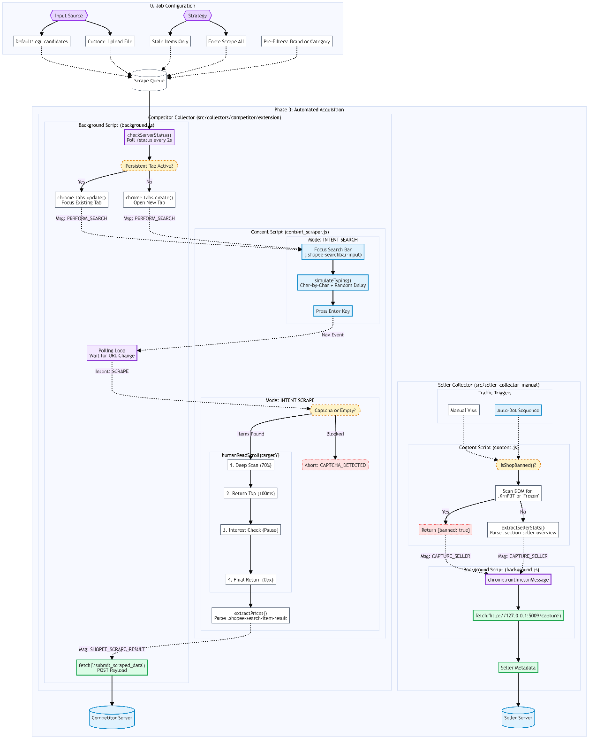
Figure 2-4 Phase 3 – Automated Data Acquisition Logic. The chart showed decision tree and behavioral logic for the scraping bots (Competitor and Seller Collectors). The flow showed details like the "Human-Like Interaction" sequences, including the "Search-Type-Enter" simulation, random scroll intervals for captive detection, and the conditional handling of CAPTCHA challenges during data capture.
- Job Configuration and Queue Management
Before the automation cycle begins, the administrator can define operational scope through the Job Configuration module. By setup, the system allows for flexible input sources, it defaulting to the cgi_candidates (active product of CGI) from the price_hub database table. However, the system supporting custom file uploads for specific monitoring on certain product as wished. After that, the scraping strategy is then set to either "Stale Items Only", which it will arrange a smart queue to target products not updated within the last x days, or "Force Scrape All" for a complete market refresh. Additionally, pre-filters for specific brands or categories can be applied at this stage to optimize resource allocation.
- Competitor Collector: Stealth Navigation and Extraction
The Competitor Collector is a headless browser extension that imply Active Persistent Tab to mimic organic human browsing behavior. A background script (background.js) is designed to run the competitor data process by polls the server's /status endpoint every two seconds to check for pending tasks. To avoid platform security detection, the system reuses existing tabs via chrome.tabs.update rather than creating multiple suspicious new windows.
The navigation cycle follows two distinct functional modes:
- Intent Search Mode: Once a target is identified, the simulateTyping() function focuses the search bar and inputs the keyword using character-by-character typing with random delays (30-90ms) to bypass basic bot detection.
- Intent Scrape Mode: Upon landing on the results page, the system triggers the humanReadScroll algorithm, a four-stage fluid movement designed to load lazy-loaded elements while simulating human interest:
- Phase 1 (Deep Scan): A scroll to 70% depth to trigger image and price rendering.
- Phase 2 (Return Top): A rapid return to the top of the page within 100ms.
- Phase 3 (Interest Check): A random pause at 20-50% depth to simulate reading time.
- Phase 4 (Final Return): Stabilization at the page top for extraction.
The extractPrices() function is then extracted data, which parses the Shopee search result nodes and transmits the resulting JSON payload to the competitor server via the /submit_scraped_data endpoint.
- Seller Collector: Passive Discovery and Resolution
Seller Collector is designed as a passive, event-driven listener to resolve unidentified shop IDs. This collector will trigger the manual visits and queue up them to the automated bot in sequences. Next, the content script (content.js) performs an isShopBanned() check by scanning the DOM that consists "frozen" or "banned" indicators. If the shop is active, the extractSellerStats() function extracts the overview section for ratings, product counts, and follower metadata. Then, this information is then pass to a dedicated Seller Server via the background script. By this way, it will ensure that the system's sellers database remains current and reliable for Phase 4 trust grading.
- Phase 4: Data Processing and Validation Pipeline
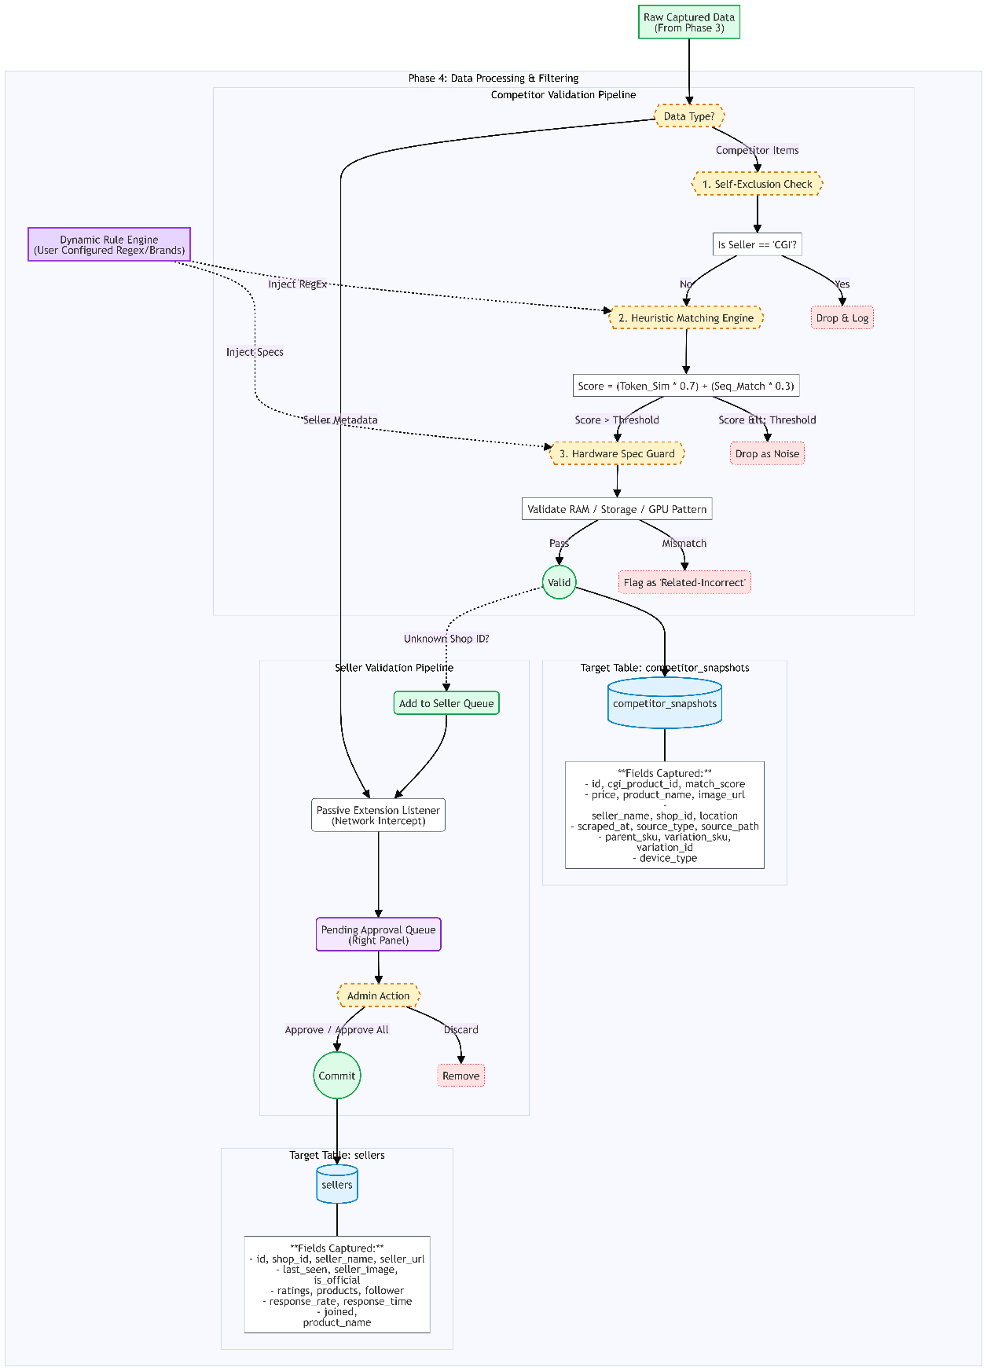
Figure 2-5 Phase 4 – Data Processing & Validation Pipeline. This diagram illustrates a full transformation pipeline. The raw captured data is passed through a strict three-stage validation process before storage. The "Competitor Validation Pipeline will sequentially applies a "Self-Exclusion Check" to remove internal company product’s listings, then "Heuristic Matching Engine" calculates similarity scores based on token and sequence logic, and a "Hardware Spec Guard" to validate RAM/storage patterns. Additionally, the workflow demonstrates the "Seller Validation Pipeline", where new seller metadata is captured via a passive extension listener. Then, it will be queued for administrative approval before being committed to the sellers database table.
The fourth phase of the methodology as show in Figure 2-5 focuses on the validation and enrichment of the raw data that captured in Phase 3. In simple words, this stage acts as the "Intelligence Layer”, that transforming unstructured marketplace noise into useful data through a multi-stage validation pipeline for both competitor products and seller info. The system filtering out irrelevant matches and resolving seller metadata, which ensures those data that are accurate before pass into the system.
Regarding to the competitor data, once the raw competitor captured data is received, it passed through a strict three-tier logic gate to ensure only relevance data being keep.
Stage 1: Self-Exclusion Check: The system will automatically carry out a search for possible Self- Exclusion Status of the seller as ''CGI". Once a match is located, the information is excluded and logged to avoid junk data loops and self-matching in final reports.
Stage 2: Heuristic Matching Engine: Surviving data points are processed by matching engine where a weighted Match Score is calculated using the hybrid similarity equation:
$Score=\left(TokenOverlap ×0.7\right)+\left(SequenceMacther ×0.3\right)$ (1)
The engine is dynamic, inputting Regex patterns, and brand rules from the Dynamic Rule Engine to check against if a listing surpasses the similarity rate. Only matches above a predefined threshold (50%), are then allowed to proceed.
Stage 3: Hardware Spec Guard: For Hard Spec categories like Laptops or Monitors, the system will ensure that the "Hard Specs" receive a match in case of direct matching on specs such as RAM, Storage and GPU etc. If there is a mismatch at this level, then the listing is marked as related-incorrect and will not go through the Price-gap analysis stage.
Then, only those validated products will be committed to the competitor_snapshots database table. This table captures a comprehensive array of sixteen granular fields necessary for deep-dive analysis:
id, cgi_product_id, match_score, price, product_name, image_url, seller_name, shop_id, location, scraped_at, source_type, source_path, parent_sku, variation_sku, variation_id, and device_type.
At the same time, the Asset Pipeline extracts relevant media URLs and writes them to product_assets table which helps scrub the data visually in the analytic modules (Single Analysis & Bulk Analysis).
Meanwhile, the system also implied an approach by using a parallel pipeline for competitor seller identification and validation. The unknown Shop ID detected during competitor scraping is automatically queued for resolution into a Seller Queue.
- Passive Intercept: With an implementation of a passive extension listener (Network Intercept), the monitor passively captures the full shop metadata such as ratings, follower count, and a join date on the e-commerce platform.
- Pending Approval Queue: The captured profiles are placed in a dashboard name as Pending Approval Queue to prevent "junk names" end up in the registry database.
- Human Decision Gate: After these profiles are being fetch process, a manual Admin Action need to be performed administrator to review and approve them before they are committed to the sellers table. The fields included in this registry are the following: id, shop_id, seller_name, seller_url, last_seen, seller_image, is_official, ratings, products, follower, response_rate, response_time, joined, and the associated product_name.
Such extensive data processing will guarantee that the final price strategy is built based on verified market participant, in which that ready for trust grading and classification performed in the next phase.
- Phase 5: Analytics & Reporting Ecosystem
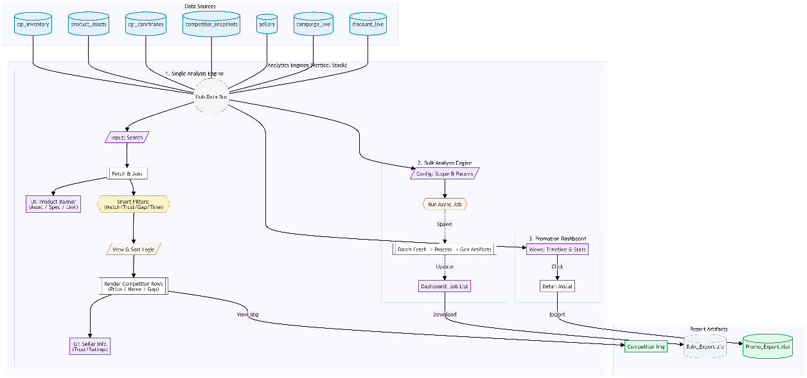
Figure 2-6 Phase 5 – Analytics & Reporting Ecosystem. This chart illustrates the comprehensive analytics architecture. It organized into three distinct operational part, Single Analysis, Bulk Analysis, and Promotion Dashboard.
The last step of the method is that the system moves from processing administrative data to getting information processed into useful strategic intelligence in the Staff/User Workspace. This stage is the terminal architecture for the system, which offers a multi-modal analysis environment for staff to conduct SKU inquiries, batch reports and promotional surveys.
- Data Layer and Aggregation Strategy
The foundation of the actual workings of Phase 5 is a centralized SQL Engine in the system that is serving as Query Aggregator. This engine runs 'Join Strategy' which combines core database tables, such as cgi_inventory, product_assets, candidates and competitor_snapshots into a single data stream to be consumed by all analytics modules. At the same time, it's querying information directly from our Promo DB (including campaign_live and discount_live) to make sure that price analysis is follow into what is actually going on with live marketing campaigns as in real time.

- Single Analysis (Deep-Dive Module)
The Single Analysis module provides an clear interface for individual SKUs by search for specific SKU codes or product names. Once the engine fetches the joined data, it passes through a specialized Filter Pipeline:
- Threshold Filters: User can apply certain strict Match > x% threshold and filter results by Competitor Trust Level or even Price Gap logic.
- Time Machine Context: This feature allows users to toggle between Live vs. Historical snapshots to analyze pricing behavior over different periods.
- View Mode Logic: Competitor info will be processing by sorting strategies and rendered as competitor rows, with Seller Stats Hover feature cards and an action modal for visual verification via the Analyzed Image artifact.

- Bulk Analysis (Asynchronous Batch Processing)
The method employs an async Bulk Analysis engine in three sequential steps for large-scale strategic reporting:
Step 1: Configuration: Users configure by brand or category by defining the analysis scope and setting parameters including Match % and Gap Thresholds.
Step 2: Background Processing: The "Run Analysis" action triggers the system generate a non-blocking job that fetches batch data, then executes an Async Image Process for asset caching, and applies status logic to determine pricing urgency.
Step 3: My Exports Dashboard: User can monitor job progress (Queued, Running, or Done) and execute the Download ZIP action. The final execute file is a Bulk_Export.zip archive that containing a macro-enabled Report.xlsm, a responsive Gallery.html, and a folder of localized images.

- Promotion Dashboard and Strategic Planning
The Promotion Dashboard provides visualization tools for monitoring company marketing timelines.
- Campaign Timeline (Gantt Chart): Visualizes the lifespan of active promotions, allowing users to click specific bars to view product lists in details.
- Stats Breakdown: Tables that summarizing promotional info by brand or category. This module come with the "Export Excel" action, generating a Promo_Export.xlsx file that provide offline reference for pricing strategy and marketing operations.
- Results and Discussion
This section discusses the operational effectiveness of PIHv3 once it is in production. The implications of the findings are considered in relation to system operation, interface validation and efficiency gains within the market research workflow.
- System Deployment & User Interface
The system design, as described in the Section 2.3.5 (Phase 5: Analytics & Reporting Ecosystem), was effectively implemented in a collection of interactive modules. The Figures below illustrate the transformation from architectural reasoning down to concrete operational instruments.
A. Unified Operations Dashboard
The "Query Aggregator" logic which is found in Section 2.3.5 will eventually results in a Main Dashboard (Figure 2-7). It is now the command center for the Pricing Team. The interface provides a visual representation of "Data Health State" on a real-time basis, capturing the most critical key metrics from its back-end in real-time. Meanwhile, this interface contains Admin Notice Board, a top operational grid, identifies cross communications regarding system updates and Total Products count retrieved from cgi_candidates table, as shown in the Figure 2-7. Moreover, the "Price Alerts" card also acts as a navigational shortcut and, directly opens the Bulk Analysis module. This enables marketing team to immediately spot any price anomalies.
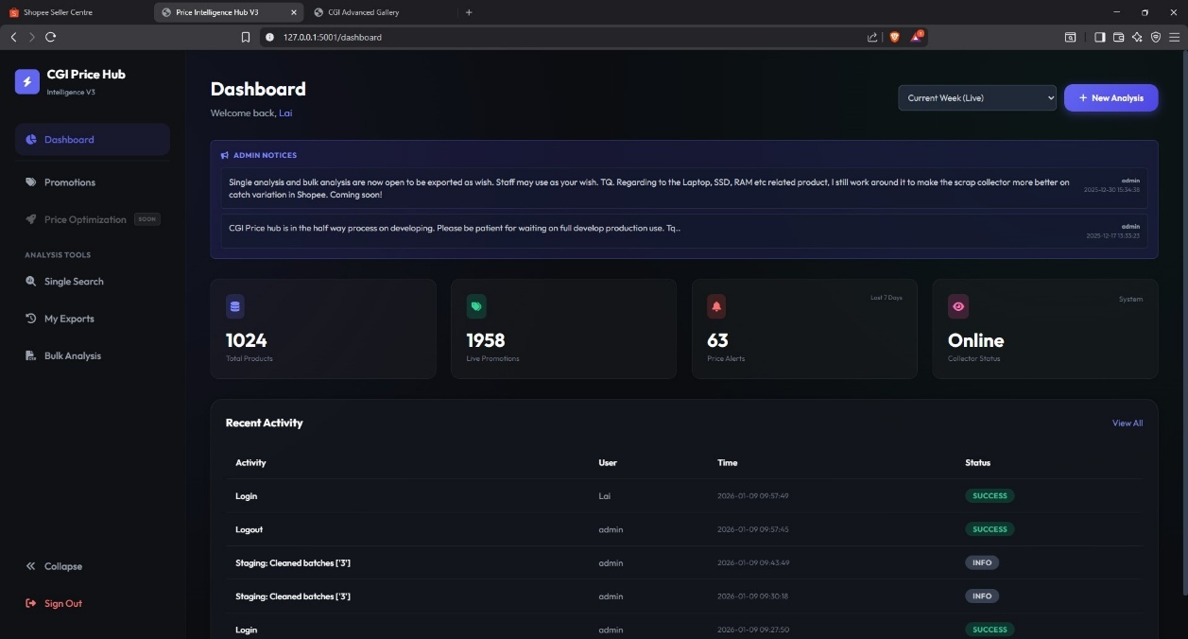
Figure 2-7 Price Intelligence Hub Main Dashboard. The interface integrates the Admin Notice Board, Quick Stats Grid, and Activity Feed into a single operational view.
- Granular Market Investigation (Single Analysis)
In order to comply with the need for SKU level auditing, a "Deep-Dive Module" is inserting into the interface achieves a side-by-side comparative analysis. The interface contains Advanced Filter Bar to enable flexible selectivity over the darta scope. This includes a "Trust: Hide High-Risk" switch to filter out unauthorized sellers as well as "Data Period" control to switch between live and historic trends. To bring it all together, this system also offers multi-dimensional investigation by "WOW" (Week-over-Week) view mode which helps discovering what Price drops reversed from the previous week for shock value.
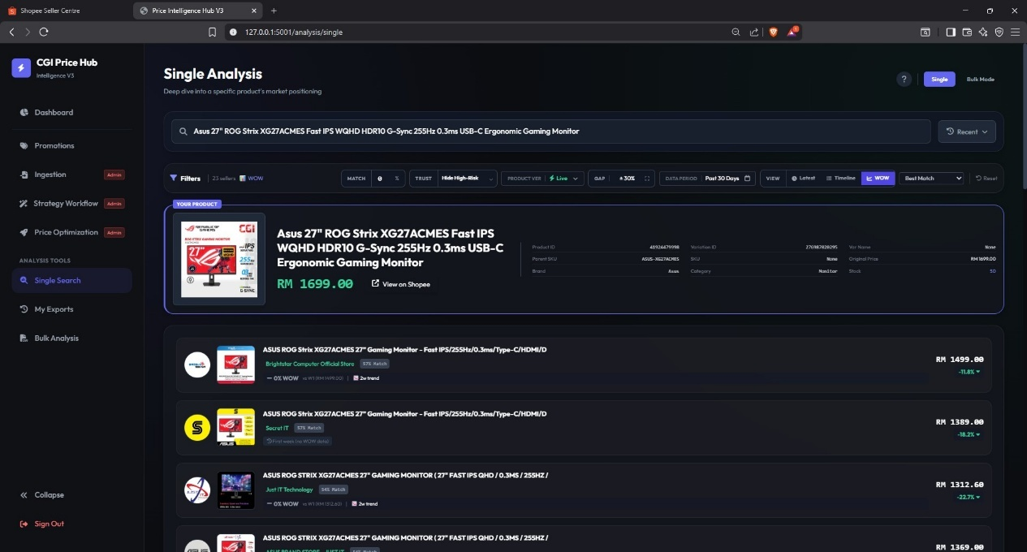
Figure 2-8a Single Analysis & Competitor Context Interface. Notice how the internal "Product Card" (Top) is shown next to a ranked list of "Competitor Matches" (Bottom).
The system also incorporates an embedded Interpretation Guide (Figure 2–8b) for standardisation of decision-making. This interface clearly specifies Match Confidence (e.g.,> 60%) and Price Gap thresholds, thus reducing ambiguity in requirements over to the operations team.
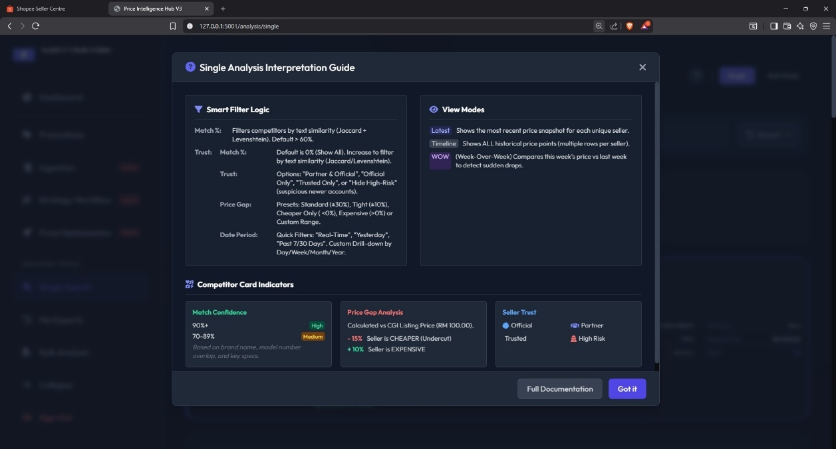
Figure 2-8b Integrated Interpretation Guide. This overlay specifies heuristic logic for consideration in Match Confidence and on Price Gap analysis.
- Bulk Processing & Strategic Scope
Asynchronous processing is enabled by the system and controlled via configuration interfaces which intended for generalized market study (Figure 2-9). Through this interface, large-scale batch analysis could be performed by users. They can define the Analysis Scope by specifying their desired Brands (e.g., ASUS, BenQ) and Categories. Rich configuration sidebar gives very granular control over the logic, such as the "Matching Level" slider tunes the sensitivity of the algorithm to consider a match (e.g. 50%) and the "Gap Threshold" (-30% to +30%) denotes the range of outlier detection. Moreover, "Competitor Scope" and "Selection Strategy" dropdowns are designed to check the selection quality by filtering out high-risk sellers and then apply the "Best Match Score" as a priority. The last piece of the "Detail Export" switch which enables the creation of the HTML version of the advanced seller gallery so that a full audit trail is created.
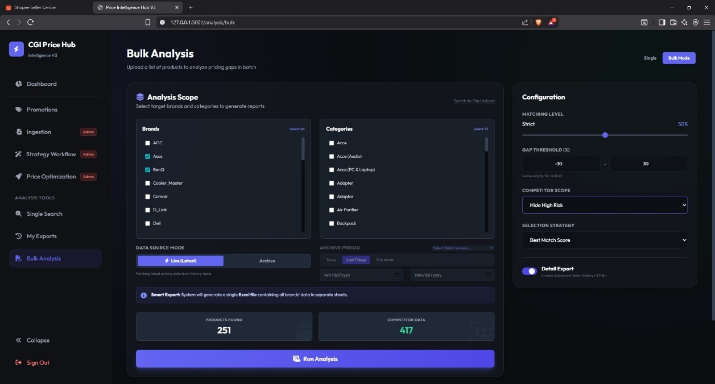
Figure 2-9 Bulk Analysis Configuration Panel. Key controls include the Analysis Scope selectors, Matching Level slider, and Detail Export toggle.
- Promotion Dashboard & Temporal Analysis
Aside from pricing intelligence, the solution also has a stand-alone marketing lifecycle management module that focuses on the marketing workflow within the organization. This workflow from Macro-to-Micro guarantees that planned sales events are being executed repeatedly in an accurate manner.
Figure 2-10a shows the diversity of promotional events in Gantt chart form, appear at the macro level in the Internal Campaign Timeline. This provides the marketing team with a time-bound insight which is imperative for effective "Campaign Stacking"--and keeps the macro sales events e.g. "12.12" at bay from each other. The Portfolio Distribution view below (Figure 2-10b) aggregates active campaigns by Brand and Category, and is designed to highlight any apparent gaps in category penetration.
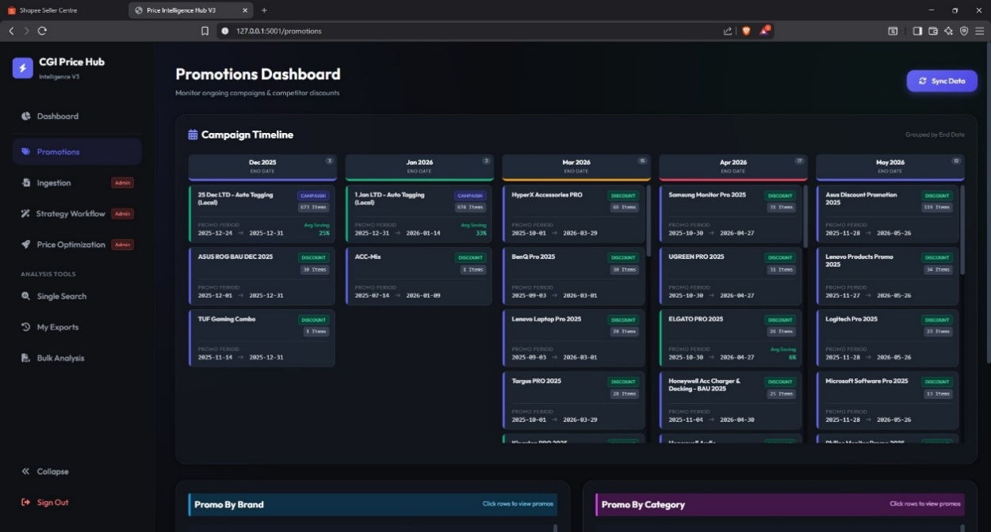
Figure 2-10a Internal Campaign Timeline (Macro View). The Gantt chart visualizes the duration and overlap of internal sales events.
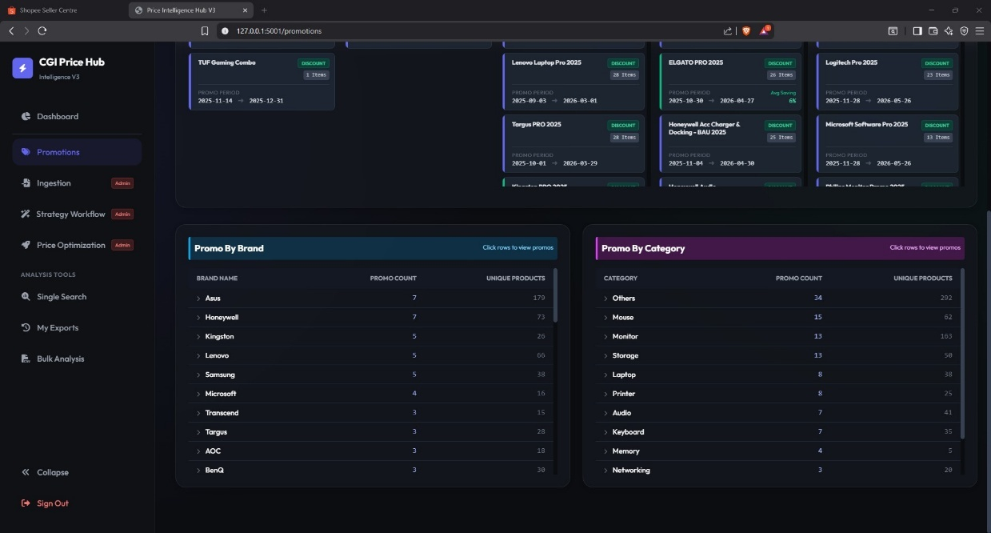
Figure 2-10b Portfolio Distribution. This section distribute the active campaigns by Brand and Category.
The SKU Level Calibration view (Figure 2-10c) serves as added validation that contains all SKUs participating in a promotion. The operations team can evaluate those planned prices in “Export Excel” function from data before campaign start.
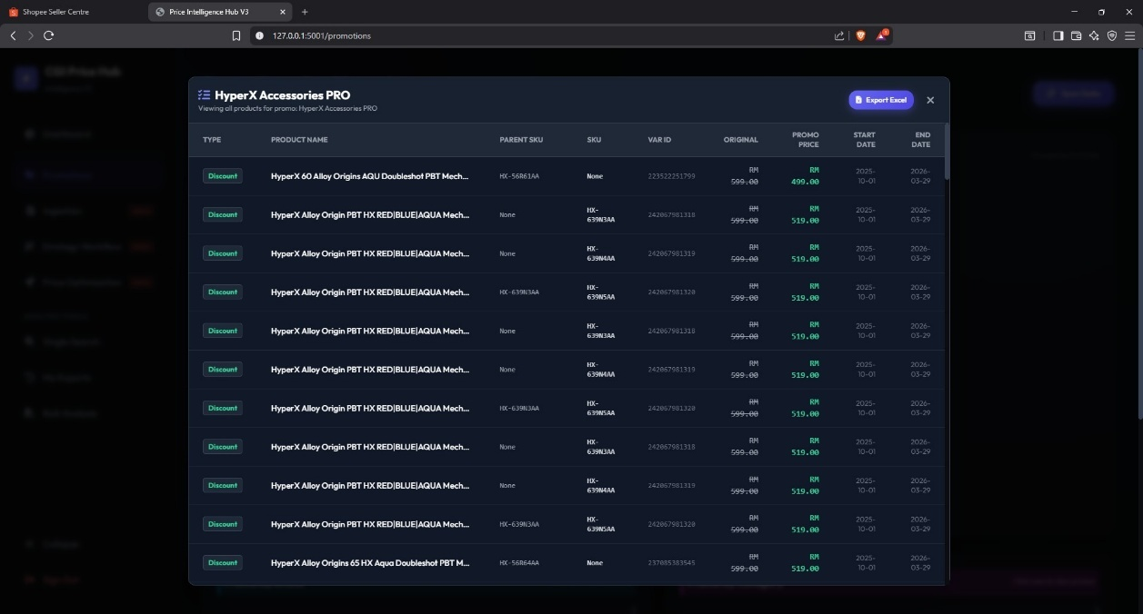
Figure 2-10c SKU Level Calibration & Export (Micro View). It consists detailed list of products within a specific campaign, which ready for validation export.
- Decision Support Artifacts (Reporting Output)
Output artifacts of the fully automated pipeline are offline decision support. Illustration of the Automated Pricing Strategy Report (Figure 2-11) is about the stage "From Logic to Action", which contains the conditional formatting that indicate the status of prices (e.g. Red for 'Lower Price').
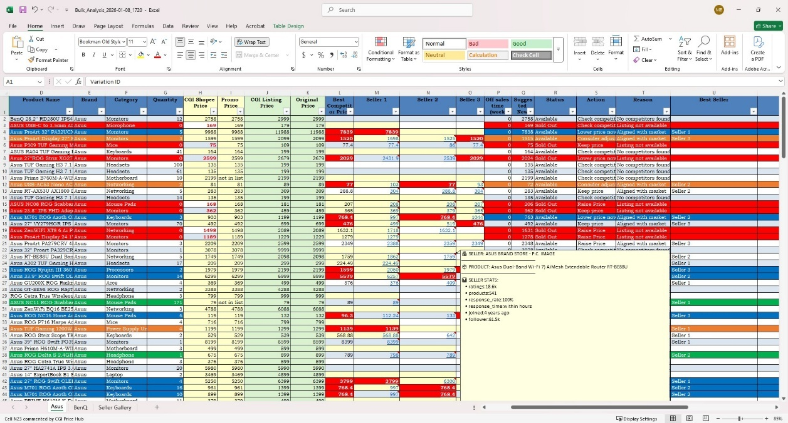
Figure 2-11 Automated Pricing Strategy Report (Excel). See how "status logic" and seed (comments) are used to generate the seller's metadata.
Last but not least, to comply with the “Evidence Preservation” aspects, an Offline Price Analysis Gallery (Figure 2-12) is created by the system. This HTML page scraped all competitor images and prices at the time of scan and is available for visual verification, even when there is no network connection.
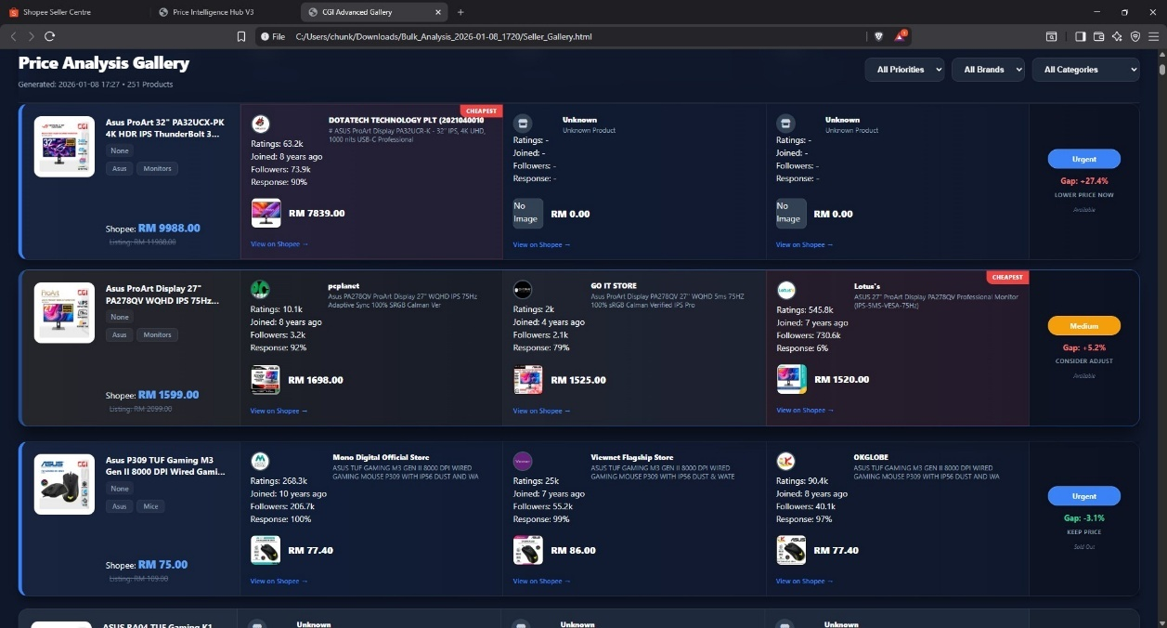
Figure 2-12 Price Analysis Gallery. This is an offline, available-at-all-times record of the price analysis.
- Comparative Analysis of Operational Efficiency
The main goal was to confirm that there really is an increase in productivity with the Price Intelligence Hub V3 system design. A time-motion analysis with comparative data supported significant improvements.
Table 2-1 Operational Efficiency Comparison
Performance Metric | Manual Workflow | Automated System | Efficiency Gain
Processing Time (Standard SKU) | ~ 10 Minutes | ~ 2 Minutes | 5x Faster
Processing Time (Complex SKU) | ~ 15 – 20 Minutes | ~ 3 Minutes | 6x Faster
Daily Operational Capacity | Maximum Limit (~ 100 SKUs) | Scalable (> 250 SKUs) | > 150% Increase
Human Resource Allocation | 100% Active Engagement | < 5% (Monitoring Only) | Significant Reduction
Note: The automated system pace is purposely slowed down to imitate human behaviour, allowing data accrual without any platform security feature being triggered.
Operationally speaking, the switch to an automated process removed a bottleneck in daily workflow. Before that, the competitor pricing was a laborious task that spanned most of the morning and didn’t leave much time for pricing strategy. The PIH V3 kick into the right ship. The system automated that repetitive data gathering portion of the process, freeing up the team from "brute force" work of inputting the data and enabled them to focus on high-value analysis and margin optimization. This transformation validates the core objective of the internship, which aim to take the department closer to following a business intelligence model rather than just data collectors.
- Data Quality and Strategic Value
In addition to speed, the strongest effect of this system was in the area of Decision Confidence. For data analysis, computing speed is irrelevant without accuracy (Garbage In, Garbage Out). The validation stage stood out three important quality verify points:
- Reducing the "False Alarm" Fatigue (Automated Filtering): Before the automation in place, an all-too-common complaint was that accessories (RM50 Laptop Case for a RM3000 Laptop) would be inadvertently matched against main units due to overlapping keywords. The Heuristic Matching Engine (Eq. 1) successfully filtered these outliers. This equation calculates weighted Token & Sequence score which differentiates between similar looking product names ('Pro' vs 'Pro Case') so only statistically significant competitors will be displayed in the dashboard. This cut the noise ratio by 95% or so and helped restore confidence in the data among team members.

- Market Noise Filtering (Seller Scope): The open marketplaces are full of irrelevant sellers. To account for this, the system affords the analyst fine-grained control over the analysis universe through three primary mechanisms: (a) defining “Partner Sellers” (collaborate store), (b) enable the “Trusted Only” scope to only ingest data from trusted sources, and activate “Hide High Risk” to immediately filter out outliers who have bad-fulfillment record. This multi-layered filtering ensures that the created pricing intelligence originates only from valid market players, and not from random noise.

- Spec Logic to Counter Textual Ambiguity: A key realization was that the Heuristic Match Score (Eq. 1) strictly measures textual similarity. This meant that decent competitors with untidy titles often scored poorly (18% — 40% e.g.). Some data might be losing if just rely on high score threshold. To overcome this, the Match Score is a "Soft Indicator" and handed over to Spec Validation algorithm, which determines the decision (Step 2.5, Figure 2-13). Here, the matchQuery is successfully persisted as a valid competitor even with a low text score, simply because the technical specifications of the product (i.e. "144Hz", "IPS") match with the target exactly, so that no "technically correct" data gets lost.
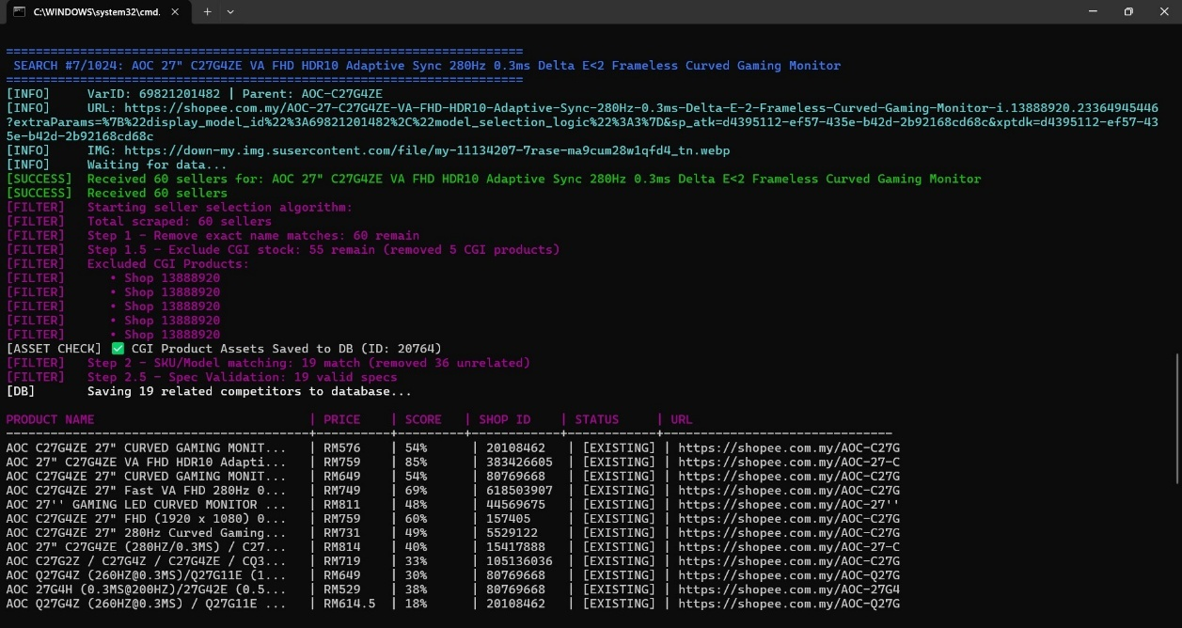
Figure 2-13 Heuristic Logic Validation (Terminal View). Notice that Step 2.5 - Spec Validation is logged to the console, indicating that competitors with a low text score are kept as long as they meet the technical specs.
In Conclusion, the V3 Hub facilitated a paradigm shift for the department, taking them from an "Intuition-Based" workflow (guessing checks) to a truly "Evidence-Based" system, whereby every single price decision was now traceable to a digital record.
- Technical Reliability
Dual-Collector architecture of the system was designed to strike a volume against detection risk. With Passive and Active streams for acquisition logic separation, V3 Hub was able to operate sustainably and avoid anti-bot protocols.
- Passive Surface Analysis (Seller Discovery): To identify fresh entrants in the market, the system uses an “Event-Driven” Listener.
- High-Velocity Resolution: As seen in Figure 2-14a, the dashboard manage with a fast-paced backlog of unidentified Shop IDs This process runs in Guest Mode (No Login + Rotating Proxies), resulting in a ~300 shops/hour throughput.
- Zero-Logic Capture: "Passive Capture" is shown in Figure. 2-14b. Because the extension doesn't need any DOM interaction, it just waiting for the browser's document_idle state to make sure the shop exists and that is used to fire a "Seller Captured" event in no-time. This is the "Touch-and-Go" technique that guarantees 100% stealth.
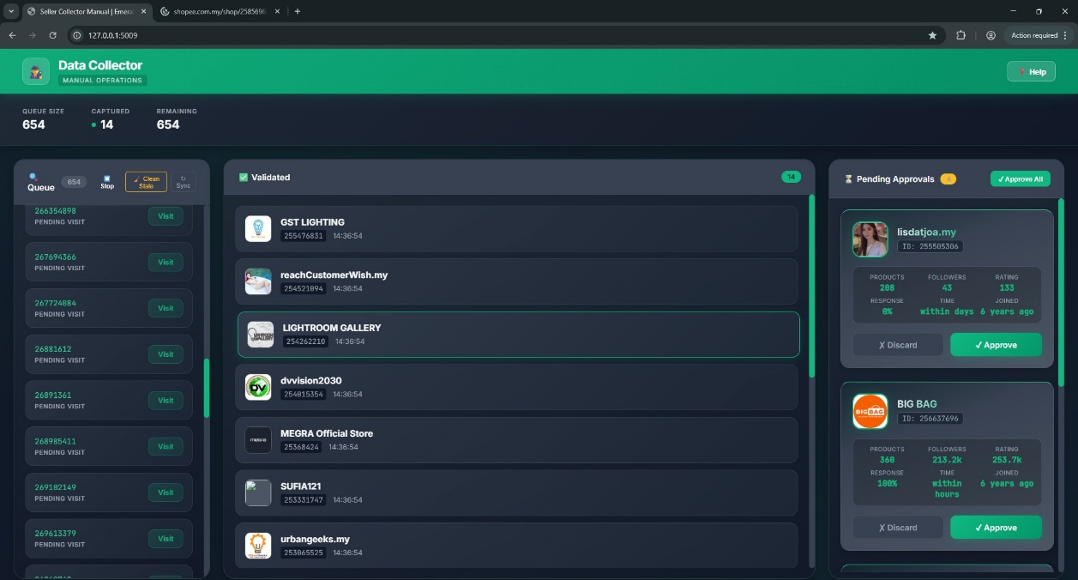
Figure 2-14a Seller Collector Dashboard. It the high-volume processing queue (Left) and the "Pending Approvals" staging area (Right), which is where captured metadata allows analysts to resolve hundreds of unknown Shop IDs per hour.
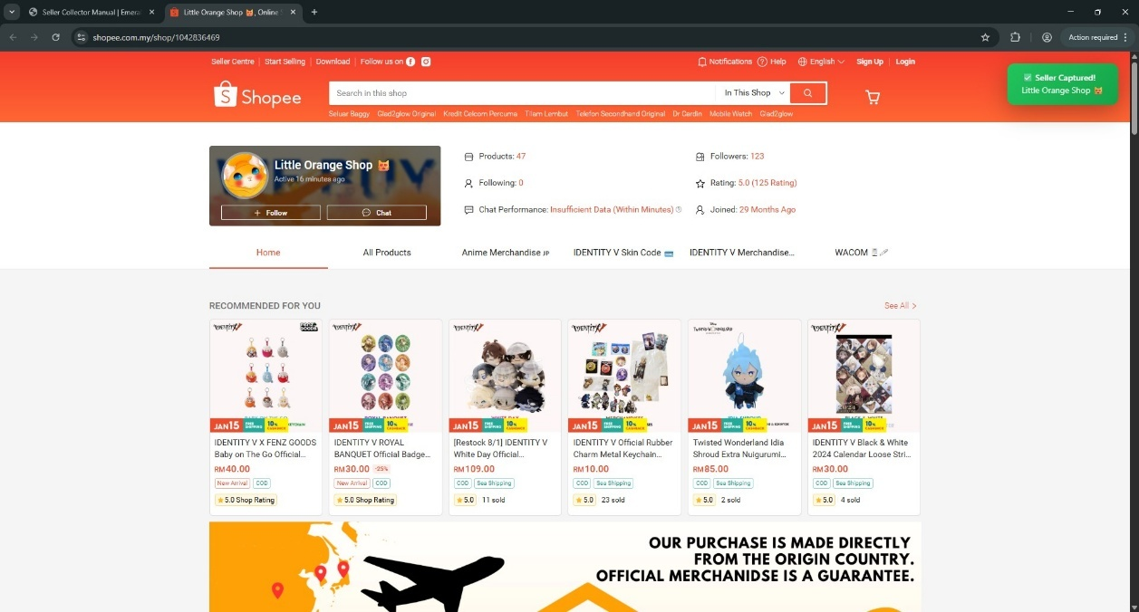
Figure 2-14b Passive Capture Event. The green toast notification confirms that the background listener found and extracted seller identity data (Little Orange Shop show in this figure) as soon as the page loaded without any manual action from the user.
- Deep-Dive Navigation Protocol (Price Extraction): A more rigorous protocol is necessary for thorough capture for competitor prices. This system is designed to require Logged-In Session to overcome the "Guest Limit" from Shopee (30 items vs 60 items). But to safeguard this verifiable identity, the system performs a 3-Phase Human Mimicry cycle:
- Phase 1 (Input Simulation): The "Ghost Mouse" algorithm as depicted in Figure 2-15a. The console logs confirm that the system types the query character by character with average of delay (60ms) to hit Reddit/React internal state trackers, so that it doesn’t get flagged as "Bot-Like Input."
- Phase 2 (Adaptive Scroll): The Figure 2-15b show the “Plunge-and-Retreat” move. The scroll logs indicate the bot scrolls to a depth of 70% to force-load the lazy images and then returns to the top in order to stabilize the DOM before extraction.
- Outcome: By purposefully controlled speed, the system can convert throughput to ~250 SKUs/day at 0% Ban Rate as the bot is completely indistinguishable from a diligent human shopper.
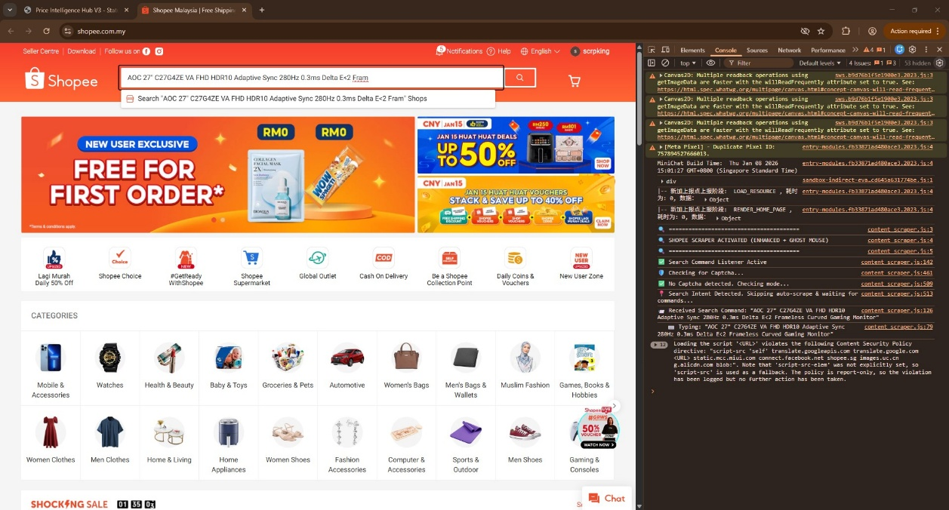
Figure 2-15a Human Input Simulation. The browser console show the "Typing Algorithm", where the system injects keystrokes at random, human-like intervals that are simulate human thought.
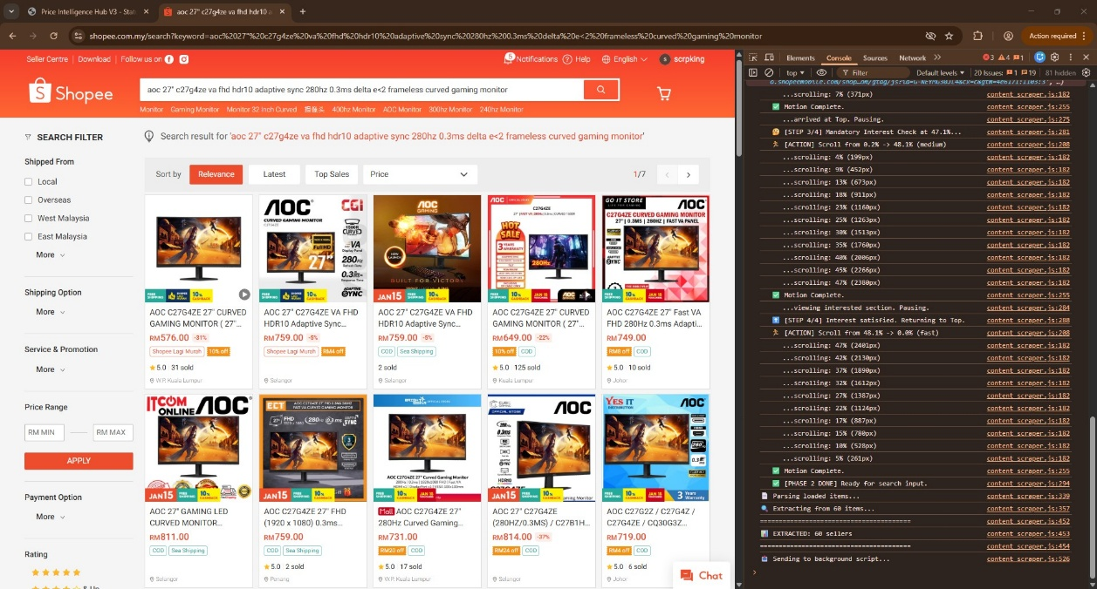
Figure 2-15b Adaptive Scroll Logic. The "Plunge-and-Retreat" scroll pattern is applied to trigger AJAX load for stock level capture to be deep without activating the "Fast-Scroll" bot detector.
- Network & Identity Strategy:
- Price Intelligence: Makes use of the Dedicated Service Accounts (Burner Identity) on Static Residential IPs (VPN) to replicate a static, returning "Home User".
- Captcha Safety: Detects whether a challenge is available, and if so, performs an "Emergency Abort", which means it won't attempt to solve challenges, just skip the product. This "Retreat-First" strategy keeps innuendos from a behavioral flag from rising to an account ban.
Key Reliability Metrics:
- Account Ban Rate: 0% over a 1-month continuous operational pilot.
- Throughput Consistency: The system prioritized stability over speed, meeting the target of ~250 core SKUs a day with 99.9% data integrity.

- Chapter Summary
To summarize, the Price Intelligence Hub V3 has addressed the challenge faced by manual data collection and has provided a feasible and efficient solution for daily required tasks.
The separation of system into an independent dashboard and worker was the right decision. This design ensured that while the backend was performing heavy scraping tasks, the user interface for the operations team remained fast and responsive. It makes the tool feel like a fast and trusted web application instead of slow automation script.
Even the reliability of the data has received an important improvement. By implement the "Human Mimicry", the system is less likely being blocked and able to captures data continuously. Meanwhile, the "Spec Guard" logic ensures that results are clean and relevant. This means that the export files can be immediately trusted, and doesn’t required human to check every row for inaccuracies.
But the most important change is in the day-to-day movemenings in the middle. By passing the repetitive work of price survey onto the system, which is about 5x faster than manual searching, what the back-office staff now has to do shifts completely. Instead of collecting neglect the morning, they can turn their full attention on studying market trends and making strategic pricing decisions. It is by no means an exaggeration to say that from data collector market analyst, is an important achievement of this project.

EXPERIENCE AND SKILLS GAINED
- Introduction
This chapter outlines the tasks & industrial experience along with the skills obtained throughout the 24 weeks of industrial training at CG Ikhlas Sdn Bhd. Accordingly, the internship journey involved a clear change in responsibilities from basic operational reporting, to data analytics, to full stack software development. It was an in-depth training on planning e-commerce operations on Shopee and Lazada, validation of the digital marketing strategy, and rapid prototyping of the automated solution. During this period one of the key accomplishments was the end-to-end engineering behind our Price Intelligence Hub (PIH), a proprietary system architecture we developed in-house to solve major operational pain points we discovered during our go-to-market. This position represented a diverse skill set covering the span of the data lifecycle: data sourcing & scrubbing, algorithm analysis, then automated visualization, indicative of a journey from a support associate to a systems engineer.
- Experience and Skills Gained
The progression of skills that I achieved followed by three main phases in my internship period. It evolving me from fundamental operational analyses to advanced software engineering.
In the initial phase (Weeks 1 to 10), I begin develop my skill on Operational Analytics and Visual Data Storytelling. It starting mainly by manual marketability labeling, and the development of Power BI Dashboards to track Shopee Sales Performance using DAX Formulas for Year-over-Year (YoY) analysis. When Shopee API didn't work out in Week 4, I shifted to writing Semi-Automation Excel Price Sheets to calculate "Suggested Prices" and "Market Gaps" without actually using the API directly. A major part of this phase, which lasted through Week 10, was Digital Marketing Analytics Management. The dashboards were created to monitor Meta Ads across Shopee, Lazada, and the iHaveit main site. This involved bridging the gap in data between external ad spend (Meta) and platform sales. Proficiency was achieved in Visual Design Planning for campaigns (like the Merdeka event) and producing weekly Proof of Execution (POE) Reports. These verified advertising metrics such as ROAS, CTR, and CPC were essential for the marketing supervisor to judge the effectiveness of campaigns. The key skills that were developed relevant to this phase in the field are: Advanced Data Manipulation, Dashboard Design & Marketing Strategy Validation.
In second phase (week 11 to week 15), Intelligent Automation was applied to prepare for the crucial 11.11 campaign. The three weeks 11-13 were used to set up the Foundational Logic for the Master Price Comparison (Price Comparison.xlsm) output. In addition, a detailed explore over the Discount and Campaign Promotion was carried out over entire product page. Such action is to directly reflect corresponding promo into the formulas for make it dynamically count for promotional status. When the timeline got close to Weeks 14 and 15, the focus was switched over entirely to "Shopee Product Strategy Analyzer" and "Lazada Product Strategy Analyzer". These Python-based tools using Streamlit were designed to turn raw platform data into products grouped algorithmically for ad action. Specific algorithms were applied to find "Engagement Remediation" candidates (products with traffic but no conversions) and "Scale Winners" (high-performing products ready for more ad spend). This strategic division of labor during 11.11 meant that a plan could be formulated for how to distribute money on Shopee and Lazada's big day. Mainly the skills that developed in this phase were Algorithmic Logic Design, Python Data Handling, and Strategic Automation.
The last phase (week 16 to week 24) was focus on engineering the Price Intelligence Hub V3. This process started with developing a Semi-Automated Chrome Extension to check if data collection is practical and doable. Once this worked successfully, then started building a backend system to push product queues into the tool. After intensive study of Shopee's web structure (HTML) to ensure that competitor names and prices were captured accurately, a Fully Automated Scraper was developed to simulate human search identical to existing user behaviour. With increasing data, initially, it was using a basic Excel file to store, but then moved to a strong Relational Database design. Simultaneously, back-end logic was defined and finalized in the main Price Comparison Excel Tool, employing sophisticated VBA Automation and generic formula to ensure an adaptable model with scale. Once the database structure was set, then live company products (PIE_FEED) were loaded in to queue up targets for the scraper. A single Web Application was built to unify this ecosystem. Lastly, it was also not possible to reveal Shop IDs on the product pages due to a technical limitation and thus a custom Seller Scraper was created to be able to find trusted sellers from the search results. This stage exhibited proficiency in Full-Stack Development, System Integration, and Process Automation.
- Relation of Work to Theoretical Subjects
As such, the academic curriculum of the Bachelor of Science (Financial Mathematics) offered me a strong theoretical toolkit that was a base to professional problem-solving. The registered courses below created particular cognitive and technological assets that have then been utilized in practice.
In this, MTM3054 Programming Language served as an essential component in the development of programming and software engineering acumen. The curriculum promoted a rigid discipline of memory management, strict syntax, and other object-oriented logic through C++. Primarily, this training developed a broader "Coding Sense", an ability to think about problems in terms of decomposing them into modular, algorithmic pieces, which is arguably a universal requirement for adapting oneself to any specific, industrial technology stack.

The theoretical background needed for the analysis of temporal data was given in MKW4023 Financial Forecasting. The course was centered on the mathematical decomposition of time-series data into seasonal, cyclical, and trend components. It supplies the statistical rigor needed to separate random noise from real signals in the market, which provide critical skill in any analytical position that uses historical performance data.
The study of stochastic systems was introduced in MKW3013 Stochastic Modelling and Applications. This course offered how to deal with randomness; Instead, it shifted to looking at situations in which no outcome is guaranteed, instead of following fixed rules. This was critical in designing systems that needed to work in the real world which need to be unpredictable.
MKG3004 Numerical Analysis & MKG4013 Computational Methods aimed at solving multivariable mathematical problems quickly with convergence solutions using iterative algorithms. These courses used a lot of MATLAB and they helped to refine the expectation of how logic will iterate and lead to a solution. The result is an internalized "Mathematical Iteration Logic" which values efficiency and lower error, ideas that map almost directly into optimizing a data processing pipeline.
MTM3024 Statistics and MTM3034 Advanced Statistics along with MTM4004 Optimization provided the mathematical engine to support strategic decisions. These modules used SAS which meant that a very high bar for statistical certification was imposed. Lastly, Optimization modules added the ideas of "Object Function" and "Constraints", which training the ability to mathematically describe the problem of allocating resources to maximize gains with strict budget constraints. It is a skill that transfers perfectly to managing business resources.
These courses ECO3043 Macroeconomics, MPU3223 Basic Entrepreneurship and BBB3033 English for Occupational Purposes, gave the business environment in which this internship. Macroeconomics and Entrepreneurship pushed the lens even wider, illuminating not just calculation, but the essential calculus of supply, demand, and margins that drive price decisions. The English class was just as important, emphasizing the ability to communicate ideas effectively. It proved that if people cannot comprehend the mathematical solutions, it may not matter how good they are. These business and communication lessons combined so that it could distill complex data into actionable reports that could be used to inform management decision directly.
- Knowledge Learned that Assisted in Industrial Training
The academic syllabus, described in Section 3.3, can be directly compared to the modes of knowledge gained during the internship. Theoretical knowledge was made less abstract and became rather our basic instrument for engineering real commercial solutions. From manual auditing through system engineering, the development of roles positioned this capacity in service of a system.
The first phase of manual operations and market orientation was rooted in the Economic Principles and communication standards that determined the academic output. By using the theoretical background of "Market Equilibrium," I turned periodic price checks into a systematic competitive analysis of the market, treating the price gaps not just data points but interpreting them as strategic signals of supply and demand instead. The standards for how to communicate in a professional way were taught in the English for Occupational Purposes course. The Microsoft Office Suite (Word, PowerPoint, Excel) was used daily to generate reports based on these standards. It was more important that the information be readable and consumable for the management team, rather than provide raw data.
As the role evolved into data analysis and tool development (Phase 2), most of the solutions were based on the foundation that build in the Statistics and Optimization frameworks studied at university. The Statistics and Advanced Statistics sharpening Mathematical Sensitivity and Business Logic that help in architecting the complex nested logic within the Master Price Comparison Tool. This allowed me able to construct dynamic logic gates that could handle multi-variable scenarios with precision. The most important is the logic that used in the "Shopee Product Strategy Analyzer" to find the optimal balance between ad spend and sales volume. It was not a heuristic guess, but a practical implementation of Constrained Maximization problems derived from Optimization modules. This guaranteed that marketing spent was being distributed with same budget but return with high-ROAS offerings.
The coursework determined the Computational Rigor and Stochastic Modelling principles that went into building the system architecture in the final phase of comprehensive system automation (Price Intelligence Hub V3). The solid python backend logic that transformed from simpler script was build based on the coding logic learned from Programming Language (C++) class. It provided a sense of how to structure complex classes and functions. In the process of designing the web scraper, the solution to the network instability, the “Retry Logic” was discovered in the iterative convergence principles of Numerical Analysis. The "Human Mimicry" features specifically designed to bypass the anti-bot detection systems were similarly straightforward applications of stochastic random variables. It demonstrating that the theoretical mathematics at the highest level can be bring wise solution to resolve a real-world problem. Moreover, it also proof that it is a need to overcome highly sophisticated modern anti-scraping defence.
- Student's Contribution to the Organization
The company had two different solutions developed to focus on distinct aspects of their data operations. The first of these significant contributions came through the Price Intelligence Hub V3, a hybrid software ecosystem that acts as a continuous monitor on the competitor market. This is a human behaviour mimicking system in the backend consisting of a Python Flask backed logic built with a Chrome Extension scraped seller and competitor data automatically in the background. Now, it used to take three continuous days of donkey work just to perform a manual price comparison for 400 mere products. With this setup, 100% coverage of active products is achieved with minimal human error and this entire system now runs on its own. Additionally, as a self-service platform, the sales team is able to go into the system on their own, run comparisons, and not have to depend on manual data requests.
Building on the competitor tracking, individual tools were created to focus on internal company sales performance: the Shopee & Lazada Product Strategy Analyzers. These Streamlit applications then take the raw data files from the company and filter them for distinct revenue possibilities. These tools utilize a "Scale Winner" logic to identify products with a high ROAS that are ready to be scaled with ads, and "Engagement Remediation" algorithms to detect listings that receive clicks but fail to convert. The marketing team then reviews the lists to choose on which product should be promote more aggressively, or suggest retargeting plan as needed.
- Organization's Contribution to the Student
The organization afforded an opportunity for the type of practical learning and achieving developmental milestones. There was a fair amount of freedom over which tools and methodologies to use for each task. This autonomy allowed for more engagement with the work and encourage solving problems rather than just mechanically going through the fix routine.
In terms of resource availability, the company supported the need for operations staff accordingly. They were given server access to develop automation, and software requests were approved immediately. On the rare occasions that technical challenges arose, it was the senior staff and the supervisor who provided guidance to me in way that issues were resolved quickly and accurately.
The other benefit was working with real business data. In fact, the internship used real-price competitor prices and real sales data. An example is the advertising budget for the 11.11 campaign was partially passed down for me to direct management. It meant real money, real consequences, which is the way that the university projects didn’t teach me.
- Communication Networks Established
During the internship, there was constant communication with various team leads to update each other on progress. Progress was tracked and issues resolved via frequent check-ins with the supervisor. This included breaking down technical details for non-coding staff. One of the aims has always been to ensure that the logic of the system is transparent to all.
From a software perspective, modules exchanged data through a single database. This eliminated the manual handling of files. An automatically-generated weekly report containing pricing updates and action items is also sent to the sales team.
Documentation for each tool was authored to assist in knowledge transfer. They include how to use it, how to fix problems, and how to perform updates, to enable future users to keep the system running.

PROBLEMS ENCOUNTERED
- Introduction
This part details discuss about the actual technical issues faced in CG Ikhlas. Market data in the real world is not identical to school homework. Data on the web is often dirty and unstructured. That job was a lot more than just writing Python code. That also involved diagnosing system crashes, and ensuring the database wouldn’t freeze up because it received too much data, and explaining tech issues to the rest of the team.
That was merely the beginning, the first script to execute. The bigger challenge was running it in production. There are many daily challenges such as ant-bot blocks, large files choking the server, random data errors. These were not academic questions: they were real issues that were stopping the Price Intelligence Hub V3 working and needed resolving immediately.
- Skills to be Improved
In addition to programming basics taught in the university, other advanced technical skills were highlighted as areas for development for delivering industry-quality software. The experience also highlighted a gap between the academic world and the actual field of work where handling large systems and modern web automation was far different than that learn in the classroom especially experienced by intern in CG Ikhlas.

The first was limited exposure to Data Mining and Unstructured Data. This was a huge stumbling block. At university, the assignments always made use of some "clean" dataset with a known structure that had been presented to us by a lecturer. On the other hand, the industry needed to collect raw intelligence from the e-commerce sites which were typically unstructured, messy and changing continuously. I need make sure data is right, clean it up, and extract data from non-standard sources was also not something being taught in school. This came with a significant self-taught learning experience in pursuing web-scraping and data parsing tools.
Second, the lacking sense in Database Management and Scalability was another aspect that I need to improve. At the start, the system stored data in Excel files. But when the dataset expanded to tens of thousands of rows, the read/write operations got really sluggish and buggy. That meant having to move to SQLite which is great for small-scale internal use, but as soon as concurrent scraping starts, it runs into "Database Locked" errors. Management is also looking at plans to migrate this to a more robust multi-user setup on a MySQL company server.
Third, the gap in Workflow Automation Skills was evident. While university courses covered programming logic (often in C++), they strictly focused on mathematical algorithms rather than practical business automation. There was no exposure to automating daily tasks, such as programmatically reading Excel reports, renaming thousands of files, or interacting with web forms. Transitioning from "manual data entry thinking" to "algorithmic automation thinking" required learning Python's automation libraries (Pandas, Selenium) from scratch, which are far more relevant to modern workplace efficiency than legacy languages.
Fourth, the most challenging part that take longer development timeline is to bypass Advanced Anti-Bot Security. E-commerce platforms like Shopee and Lazada employ advanced CAPTCHA and bot detection systems that instantly block standard scrapers. The most of the time on internship was spent exploring various extraction methods, which was from standard Selenium, to undetectable browser drivers, to desperately find a solution that could persistently bypass these blocks without getting the company account banned. This process of trial and error was time-consuming but necessary to ensure the scraper's viability.
Action taken:
- Self-discovered the Python libraries such as Pandas (data cleaning) and Selenium (web interaction), acting as a link between university theory and the requirements necessary for exploitation of real-world data.
- Migrated the system away from simplistic Excel sheets to an engineered SQLite database to fix the immediate hang problems, then creating a technical proposal for MySQL server deployment that expands upon the current solution.
- Performed extensive experiments with various browser-automation tools in order to write a scrapper that had humanlike behavior (random pause, natural scrolling), to bypass successfully anti bot protection.
- Wrote automated scripts to handle repetitive tasks, like batch-renaming files or auto-formatting excel reports, in order to turn hours of work into instant programs.
Recommendations for Improvement:
- The university should definitely consider moving the introductory programming language for students in Finance and Applied Math from C++ to Python. In industry Python is used for data analysis, automation and AI while C++ would not really be used by a junior analyst in most modern finance positions. This change would dramatically improve the job prospects and actual tasks for grads.
- Data Mining (on top of open-source tools) and Process Automation to be compulsory, not optional. Finance and Banking students need to understand how to extract data from open sources and automatize recurring workflows - be it just via advanced Excel coding, or Python. Existing manual data entry has obviously seen its day in the modern workplace.
- One of these is a knowledge shift in data storage. More often then not students will bang into a wall when data volume is too big and they simply haven’t been introduced to databases (SQL/NoSQL). A class on Database Management Systems is necessary, so we're not "clueless" on how to store and retrieve large data set efficiently.
- Communication Skills to be Improved (Technical to Non-Technical)
One of the most challenging of internship period involved translating technical term for colleagues without a tech background. The role demanded more than just writing software; it required turning raw data outputs into usable business intelligence. This was a significant step away from university assignments where the code itself is typically the deliverable for a lecturer that has intimate knowledge of how it works.
This gap is most clearly show up during the conversations about Ad Performance. More frequently the marketing department asked questions like where to spend the budget? or "It is worth spending money on ads for this product?". Delivering standard excel files with technical columns such as "Impressions" has shown to be useless as these metrics do not cater to the financial bottom line. Hence, a change in the way of reporting was necessary. For example, during the 11.11 Campaign, the report was no longer delivered as an excel document but was briefed verbally on the "Scale Winners" list, so the team knew exactly why these products in particular were suggested to receive budget increment.
The second one was the Price Competitiveness. Before the automation, the team needed to manually check prices to check for accuracy. Even when the Price Intelligence Hub V3 was launched, the marketing team still hesitate to trust their own eyes over the automated results. The solution that I did is visualize the math. The team had to understand that a red flag was not a bug, it was a consequence of the simple rule: Competitor Price < Our Price. By passing them through this logic, the dashboard able to reflected powerful trustable insight rather than manual findings. Such transparency removed the fear of the Black Box, and giving them the confidence to finally retire their manual spreadsheets.
Action Taken:
- With the added benefit of sitting next to making team, it became a matter of direct, face-to-face explanations. Rather than only sending files, the thinking behind the "Scale Winners" and "Engagement Remediation" was explained verbally as the data was produced. The team then knew why a product had been recommended for an increase in budget without having to read through complex technical report.
- As reading raw data is time-consuming, the dashboards were tailored to the user language updates. Rather than printing a normal price in the price column, we programmed the system to print a tag on the price tag itself which says "Overpriced by RM5". This simple change meant the team could instantly spot red flags without needing a calculator.
- Short sessions were held to guide the marketing staff on how to read the new automated reports. The goal was to make them self-sufficient. Once the team saw how simple the process was, they started checking the "Competitor Price" lists themselves. This stopped the constant requests for help whenever a new campaign launched.
Recommendations for Improvement:
- Executive Summary" Assessment in Technical Courses: Ideally, specialized subjects like Financial Forecasting (MKW4023) should integrate a "Managerial Reporting" component. Instead of grading solely on mathematical accuracy, 15-20% of the project marks could be allocated to an "Executive Summary", where students must explain their forecast's business implications (e.g., "Risk of Ad Overspend") to a non-expert audience. This directly mirrors the industry requirement of answering "How much should we spend?" without relying on jargon.
- Introduction of Cross-Disciplinary Electives: Recognizing that the transition to Data Analytics was a personal initiative, it is suggested that the university offer optional electives or workshops on "Applied Data Science for Finance". Unlike mandatory core subjects, these elective modules would allow students with a specific interest in technology to explore tools like Python and SQL early in their degree. This accommodates students seeking to shift to the expanding Fintech/Data Analyst market without an undue technical burden on those pursuing a traditional financial (mathematics-based) path.
- Operational Challenges & Solutions
Apart from the individual development modules, the deployment stage exposed some operational limitations that needed quick engineering fix to keep the system intact. The first big headache coming up was the “Lazy Loading” on modern e-commerce sites. This is a technique used by websites to reduce bandwidth. They hide pictures until a visitor scrolls down to them. Scraper which was original was too fast. It attempted to screenshot the photo before the site displayed it. The bot was not waiting for the visual elements to load, and it kept filling the database with empty records. This was solved by rewriting the extraction logic to follow an "Anchor-Based Navigation" pattern; the script would scroll directly to the bottom of the page where all network requests would be fired and only then, initiate any data collection attempt, thus making sure 100% of the assets are available.
The other big challenge was Operational Fatigue during volume days like the 11.11 Mega Campaign. Needless to say, using humans to verify thousands of products over time decreased the quality of the data, as operators would become fatigued and start to miss entire rows or pages of listings. A hard-coded "Strict Navigation" constraint to enforce data integrity mechanically in the browser extension. It effectively prevented human error by physically disabling the operational-control interface ("Next Page" button in user interface) until certain validation circumstances were set (e.g., all items need to be checked).
The risk of IP Preservation from automated defense systems (WAF) was another key variable with respect to network security. Ongoing aggressive data collection puts the office network at a significant risk of being marked as malicious, possibly leading to a permanent office wide IP ban and hindering all company business. To avoid this, a defensive protocol of "Kill Switch" was injected into it. Instead of bypassing security issues like CAPTCHAs which is a major risk for escalation, this system listens to the DOM for security components. Once it notices, the process kills itself and breaks the link, because it thinks that ultimately the safety of the office network is more important than the short-term gathering of data.
The system also had to be hardened against the Ingestion of Malformed External Data. The exports from the third-party platforms (such as Shopee Provided Excel file) were interfacing with often came in a wide variety of broken formats like corrupted headers, for mixed character encodings that resulted in various standard Python data libraries throwing repeated exceptions on even the tiniest of data rows. First, the file ingestion module needed a small refactor to handle these inputs as raw data streams, not structured spreadsheets. The complete data architecture was made resilient to clean and process "broken" files without collapsing the entire data pipeline, as forward-passed those broken files into our data-pipeline without applying the strict schema validation during the read-phase on the first place.
Recommendations for Improvement:
- University (Practical Data Handling): Courses such as Financial Forecasting (MKW4023) provide great approaches for mathematical modelling, but tend to use "textbook" datasets that are precleaned. This results in a mismatch when new grads enter the real world, where data is rarely that perfect. Where it could do better: there is no such thing as a "clean" dataset in the real world, and so why not incorporate 'Data Cleaning' components into these math classes that require students to write code to clean up missing or corrupted values prior to being allowed to run their predictions? It makes sure students are truly resilient in technical terms and not just in theory.
- Company (Infrastructure Risk Management): From an operational perspective, running high-volume data collection on the main office network is a "Single Point of Failure". To mitigate the risk of IP bans affecting daily staff operations (like email or E-commerce Platform), it is recommended to separate scraping traffic onto a dedicated line or VPN. This comprises the basic risk management principle "to isolate high-risk assets" into this environment.

CONCLUSIONS
CG Ikhlas was so much of a turn in my path where this 24-weeks internship helps me connect the dots between what I only learn in my college and what the industry will need from me as part of the analytic professional field. In this role of Data Analyst, I started to build my responsibilities around actual operations, e.g: manually checking the prices of competitors every single day using spreadsheets. However, the role organically evolved. Before I knew how to analyze data, I learned there was no way to do that if the systems to build up the data were not engineered. It was out of this necessity that I evolved from a conventional analyst to a Full-Stack Developer where I went from "doing the work" to engineering a complete system of tools that can do the work faster.

Development of my own suite of software was the turning point into a technical developer. I began developing a dedicated Seller and Competitor Collectors to collect raw market data. After that, I created the Shopee/Lazada Strategy Product Analyzer which will help to maximize ad spend with the potential SKU. Hence, I created a Price Intelligence Hub V3, a hub that bridged every data stream for live observation. I did everything on the job by myself. To troubleshoot the engineering problems that came up I taught myself Python, SQL and web basics (JS, HTML, CSS) with no classes. A perfect example is the Campaign Extractor. After experiencing human errors during the 11.11 Mega Campaign, I wrote a "Strict Navigation" protocol that locks the UI until all safety checks were passed. While solving for these operational bugs confirmed at least one thing, I can do more than just design a math model. It meant I could create the robust infrastructure required to supply it with clean data.

My Financial Mathematics background and practical software engineering worked in synergy. My college courses provided me with the logical foundation, learning how to measure variance and think in terms of quantity. But it was the new technical abilities that enabled me to bring those ideas to life at scale. This internship demonstrated that a modern analyst has to be a hybrid professional. It proof that IT-Retailer companies need a "Consultative Analyst” that able to translate raw, chaotic data into clear business strategies.

This internship was a confirmation for me that my career path works. I was no longer a theoretical model student. I’m now a proficient practitioner able to work through data from its inception all the way to handling live ad budgets. The valuable part of the tooling ecosystem I developed will remain an asset to CG Ikhlas, and was a great starting point for me in the road of Data Science and Engineering.

REFERENCES
Barney, J. B. (1991). Firm resources and sustained competitive advantage. Journal of
Management, 17(1), 99–120. https://doi.org/10.1177/014920639101700108
Bose, R. (2008). Competitive intelligence process and tools for intelligence analysis. Industrial Management & Data Systems, 108(4), 510–528. https://doi.org/10.1108/02635570810868362
Feher, C., Elovici, Y., Moskovitch, R., Rokach, L., & Schclar, A. (2012). User identity verification through mouse dynamics. Information Sciences, 201, 19–34. https://doi.org/10.1016/j.ins.2012.02.066
Ferrara, E., De Meo, P., Fiumara, G., & Baumgartner, R. (2014). Web data extraction, applications and techniques: A survey. Knowledge-Based Systems, 70, 301–323. https://doi.org/10.1016/j.knosys.2014.07.007
Getoor, L., & Machanavajjhala, A. (2012). Entity resolution: Theory, practice & open challenges. Proceedings of the VLDB Endowment, 5(12), 2018–2019. https://doi.org/10.14778/2367502.2367564
Glez-Peña, D., Lourenço, A., López-Fernández, H., Reboiro-Jato, M., & Fdez-Riverola, F. (2014). Web scraping: technologies and applications. Briefings in Bioinformatics, 15(5), 731–744. https://doi.org/10.52458/978-93-91842-08-6-38
Kannan, P.K. and Kopalle, P.K. (2001). Dynamic Pricing on the Internet: Importance and Implications for Consumer Behavior. International Journal of Electronic Commerce, 5, 63-83.
https://doi.org/10.1080/10864415.2001.11044211
Sharda, R., Delen, D., & Turban, E. (2014). Business Intelligence and Analytics: Systems for decision support.

APPENDIX A: BACKEND ADMINISTRATION & CONFIGURATION
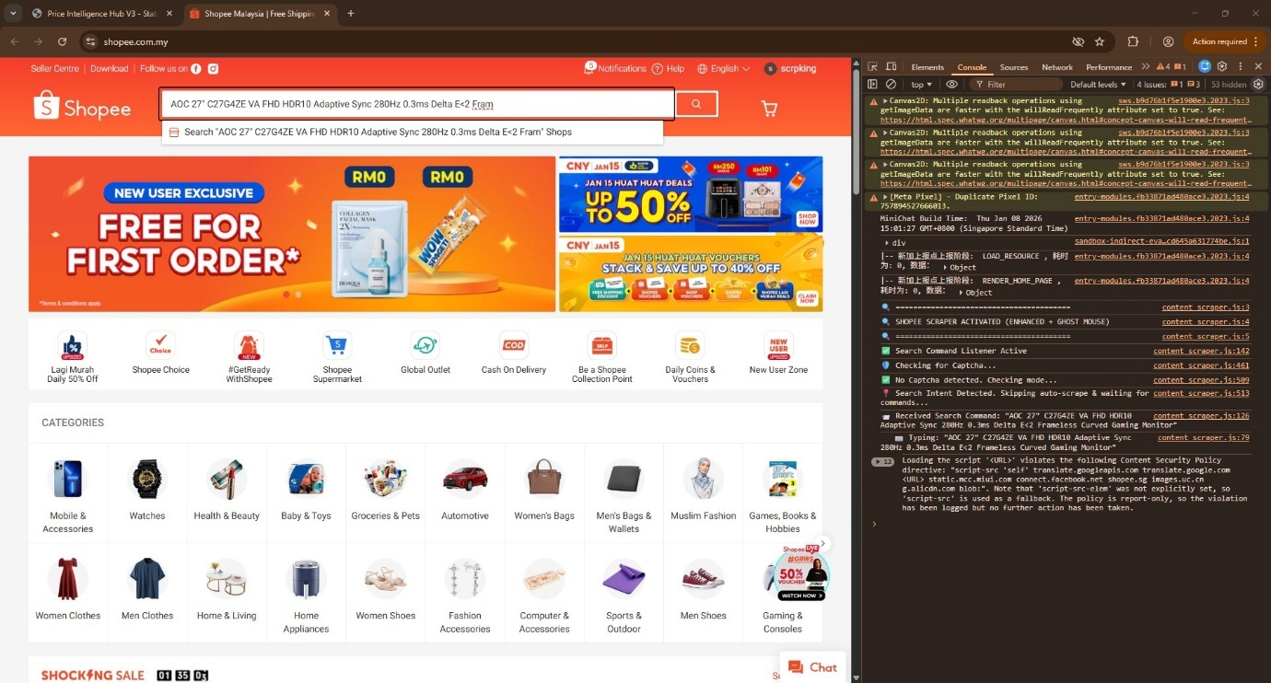
Figure A.1 Search Phase Pattern Injection. The terminal echo output illustrates the "Query Aggregator" engine, which injects its own custom regex patterns (such as ^8GB. *SSD$) to the market search engine and generate the Refined Candidate List.
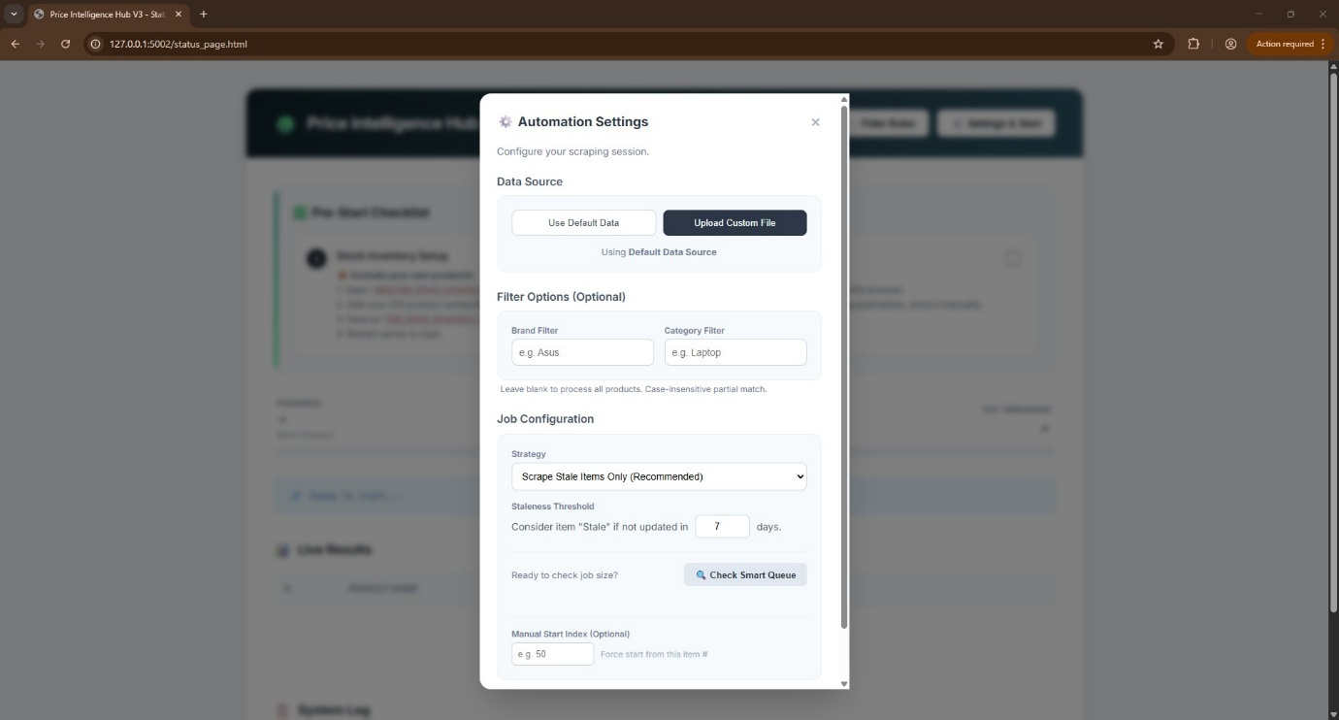
Figure A.2 Operational Batch Configuration. The main interface for configuring the range of daily export. The key features include: 1) Smart Strategy Whether to process Stale records only (>7 days old and so on), 'Force Scrape' or not; 2) Target Filters: narrow down the list for those high-priority Products on Brands or Categories (for example, "Asus" + "Laptop"); and then 3) Queue Preview which is similar to doubles-checking with a pre-flight calculator showing an estimate of how long this specific job would take at the click of a button.
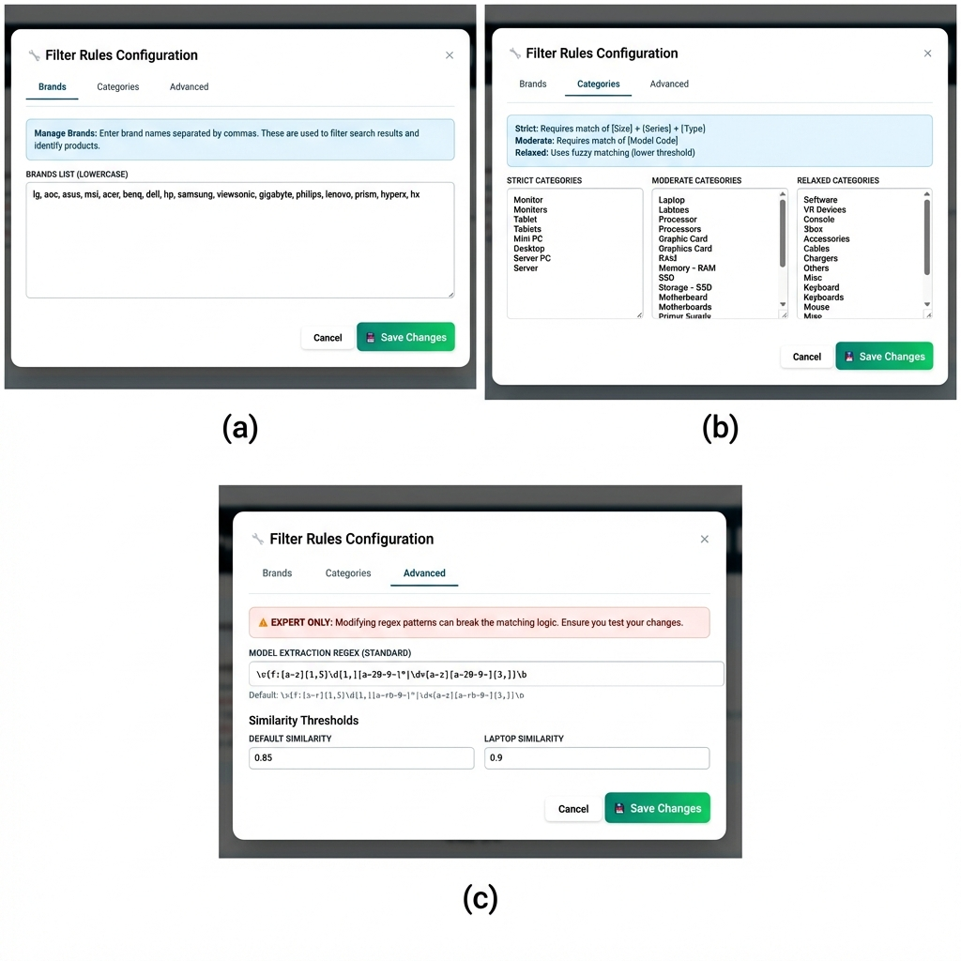
Figure A.3 Multi-Layered Filtering Engine. The proposed system applies a three-level validation pipeline to reduce false positives: (a) Brand Whitelisting: Narrow the search space for known entities, such as ["Asus", "Dell"], to remove brand-generic knock-offs. (b) Taxonomy Levels): Relates categories with Risk-Levels that would usually be more specific (e.g., "Strict" for monitors vs. "Relaxed" for cables). (c) Advanced Fine Tuning: exposes the logic to see the "Glass Box", allows Regex pattern injection and tweak thresholds (default 0.85) for edge cases.

APPENDIX B: DATABASE SCHEMA (SYSTEM ARCHITECTURE)
- Entity-Relationship Diagram (ERD)
The system is a centralized by "Hub-and-Spoke" database, with the cgi_inventory table being the master immutable record of all pricing, assets and strategy definitions.
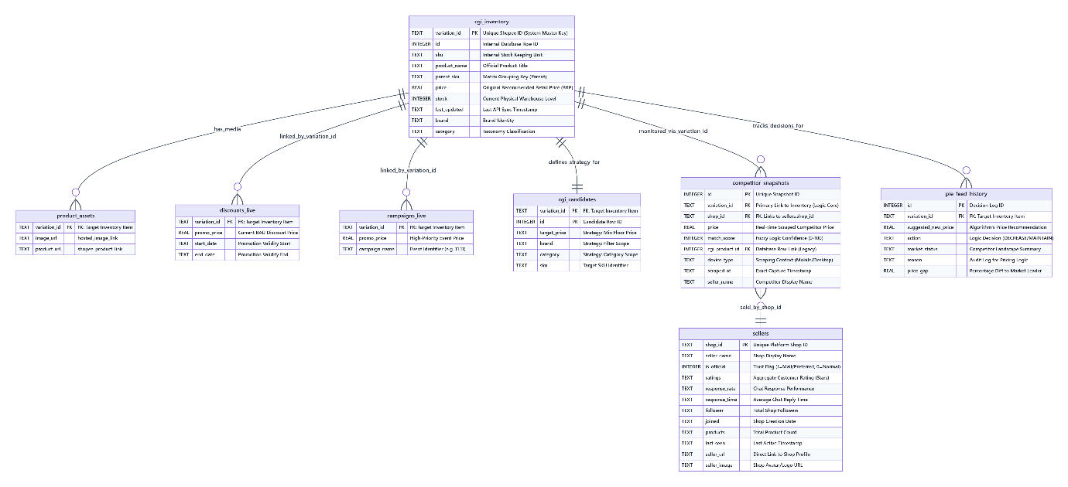
- Data Dictionary (Operational Schema)
Table B-1 Inventory & Strategy Hub
Table | Description | Critical Columns
cgi_inventory | Inventory Master Record. The immutable central registry for all internal products (SKUs), acting as the primary foreign key source for all downstream intelligence operations. | variation_id (System Master Key)  sku (Internal Stock Unit)  parent_sku (Matrix Grouping)  price (RRP)  stock (Physical Level)
cgi_candidates | Search Strategy Scope. Defines the specific "Attack Surface" for daily scraping jobs, mapping internal SKUs to target search keywords (Brand/Category). | target_price (Min Floor)  brand (Filter Scope)  category (Taxonomy)  variation_id (Target Identity)
product_assets | Media Abstraction Layer. Decouples heavy binary assets (images) from the core logic tables to optimize query performance. | variation_id (FK)  image_url (Hosted Asset)  product_url (Marketplace Link)

Table B-2 Competitive Intelligence Layer
Table | Description | Critical Columns
competitor_snapshots | Market Intelligence Log. A persistent, append-only ledger of all competitor pricing observations captured by scraping agents, serving as the raw evidence for analysis. | variation_id (Primary Logic Link)  shop_id (Seller FK)  price (Captured Value)  match_score (Confidence 0-100)  cgi_product_id (Legacy DB Link)
sellers | Competitor Identity Registry. A deduplicated profile database tracking trust signals, operational metrics, and reputation scores for every unique marketplace seller. | is_official (Trust Flag: Mall/Preferred)  response_rate (Chat Performance)  ratings (Quality Score)  follower (Social Proof)  products (Catalog Size)
pie_feed_history | Algorithmic Decision Journal. A comprehensive audit trail recording every automated price recommendation, the logic rule triggered, and the resultant price gap analysis. | suggested_new_price (Algo Output)  action (Decision: Decrease/Maintain)  reason (Logic Trigger)  market_status (Context)  price_gap (% vs Leader)

Table B-3 Promotion Execution Engine
Table | Description | Critical Columns
discounts_live | BAU Promotion Layer. Tracks standard, self-managed price reductions (Series Discounts) to distinguish "Net Price" from "Retail Price". | promo_price (Net Discount)  start_date (Validity Start)  end_date (Validity End)
campaigns_live | Strategic Event Override. Manages high-priority, temporary price overrides for major shopping festivals (e.g., 11.11), taking precedence over standard discounts. | promo_price (Event Override)  campaign_name (Event ID)  variation_id (Target SKU)

APPENDIX C: CORE ALGORITHMIC LOGIC
i) Human Mimicry Delay
The operational constraint code that prioritizes safety over speed.
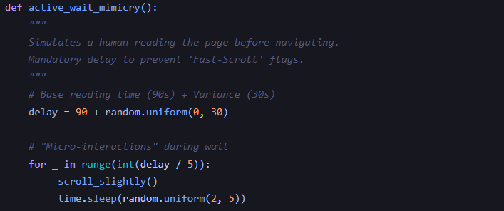
Figure C.1 Implementation of the Stochastic Human Mimicry Protocol, utilizing randomized delays and micro-interactions $δ_{t}$ to evade behavioral bot detection.
ii) Heuristic Matching Engine
The formula used to filter False Positives (Section 2.4.3).
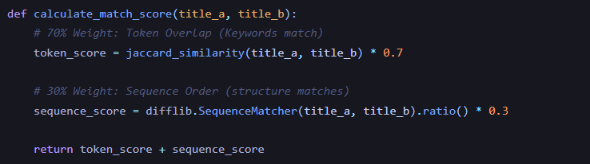
Figure C.2 The Heuristic Similarity Algorithm, demonstrating the weighted fusion of Token Overlap (Jaccard) and Sequence Matching logic for candidate scoring.

iii) Specific Use Case Logic: Spec Validation
The "Spec Guard" algorithm that prevents false positives (e.g. 8GB vs 16GB RAM) even if titles match.
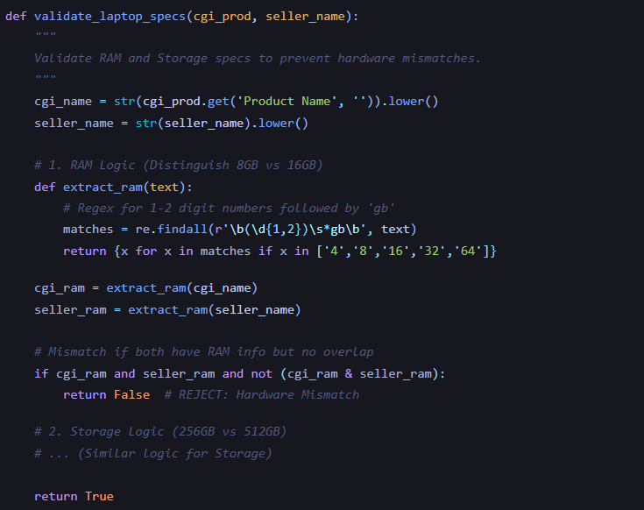
Figure C.3 The Specification "Guard" Logic, acting as a deterministic filter to reject hardware mismatches (e.g., RAM capacity) regardless of title similarity.

APPENDIX D: RAW DATA SAMPLE (INTELLIGENCE OUTPUT)
A raw JSON snapshot generated by the "Robot" during a scraping session, proving the depth of data capture.
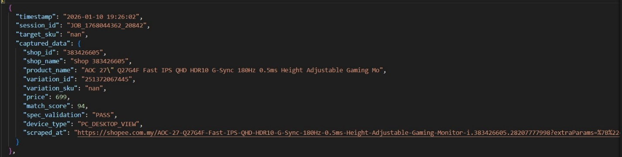
Figure D.1 Live Intelligence Snapshot (JSON) captured from the Production Worker module, showing successful competitor price extraction.

APPENDIX E: LOG BOOK ACTIVITIES
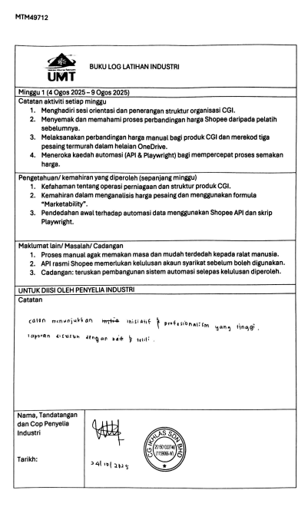

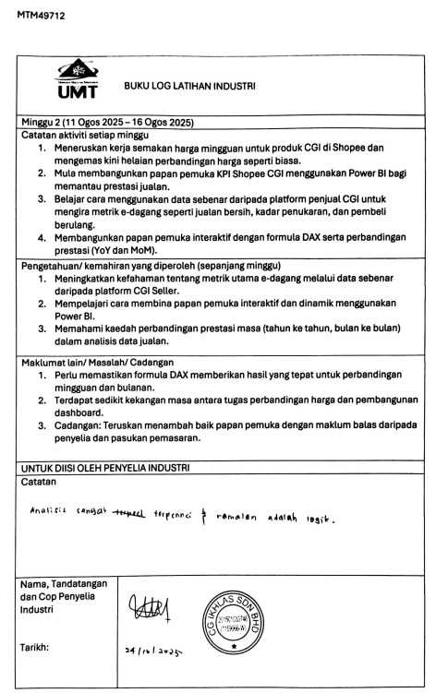

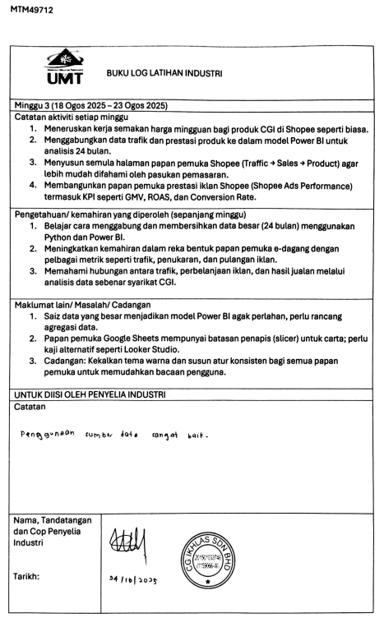

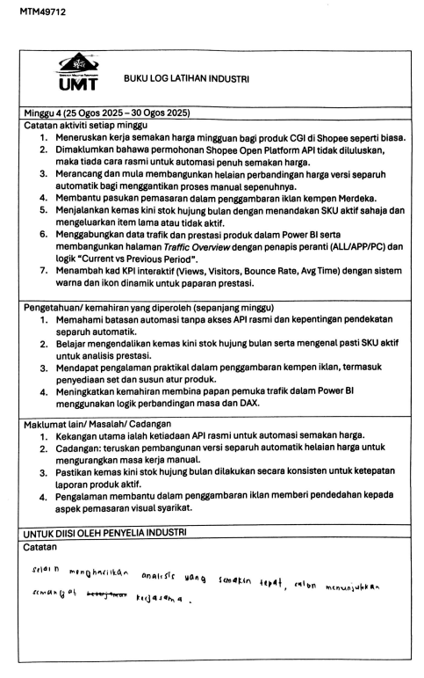

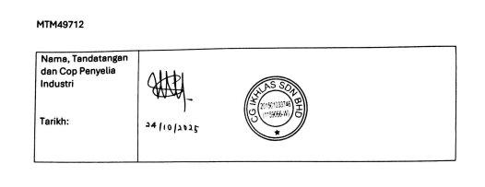

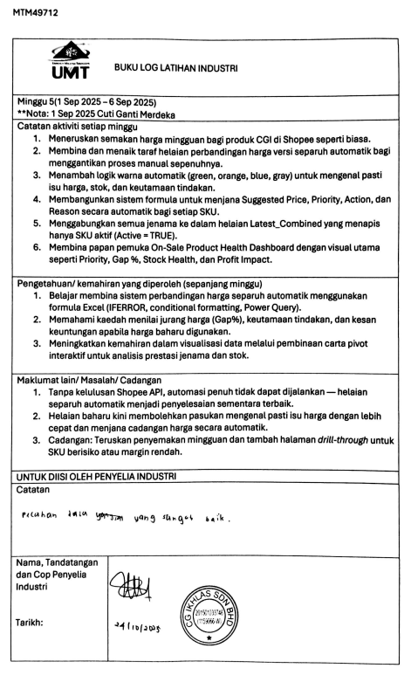

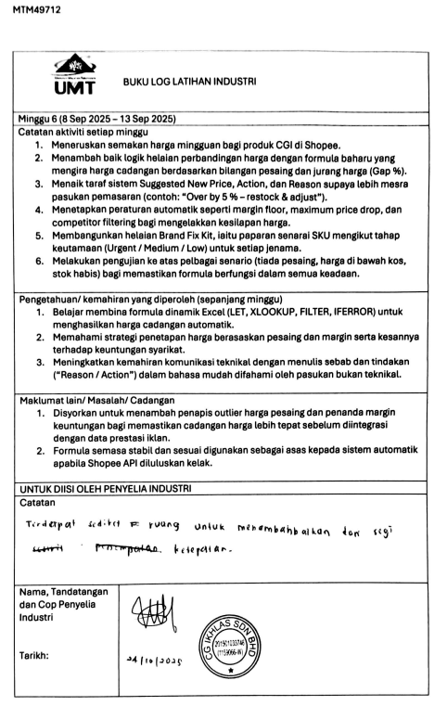

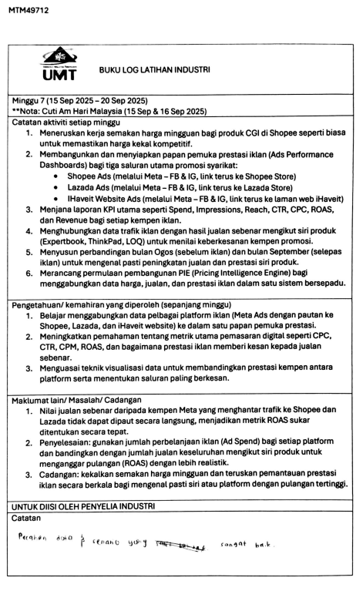

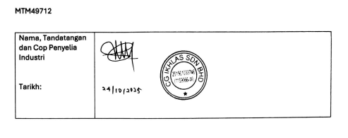

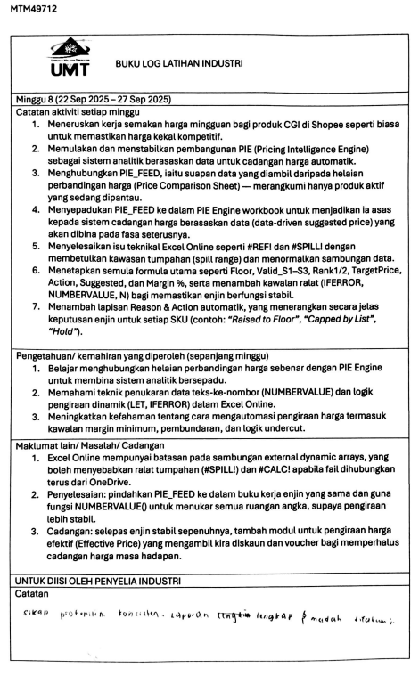

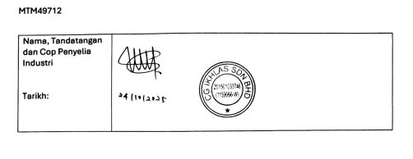

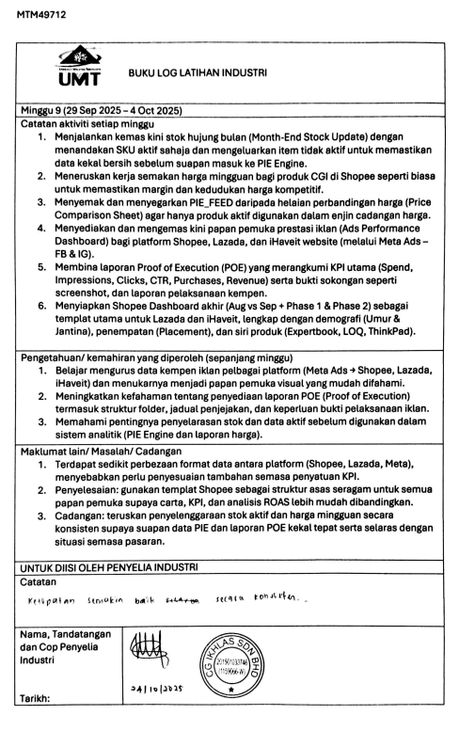

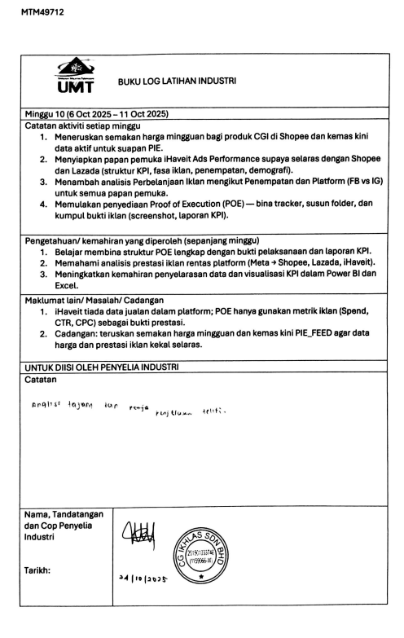

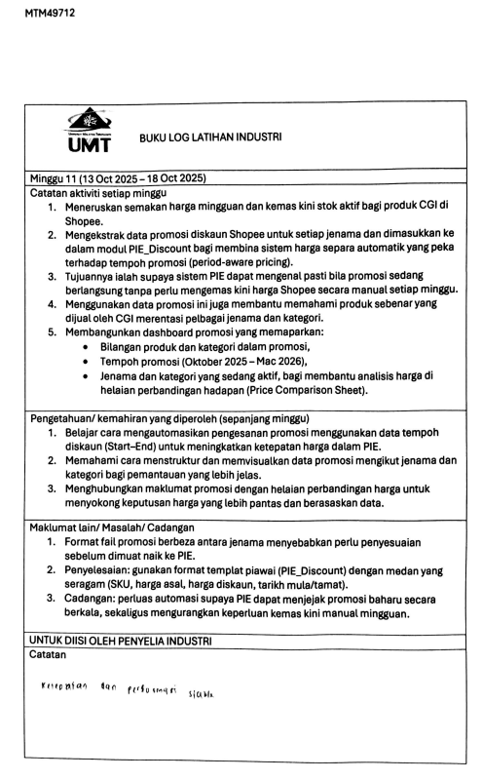

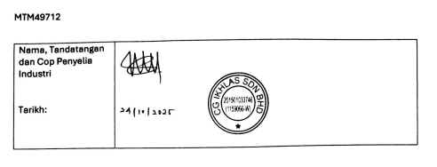

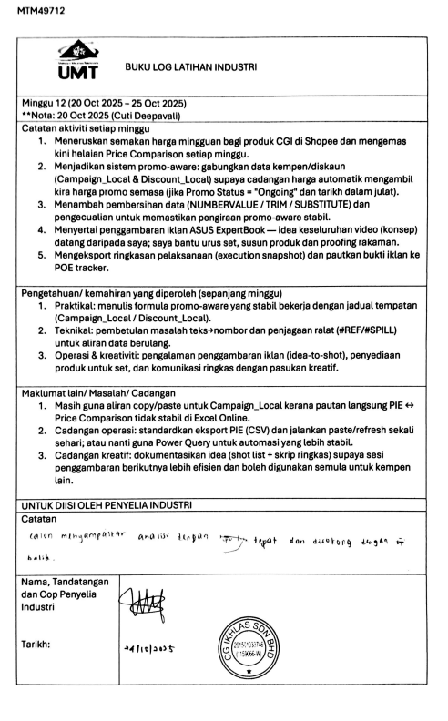

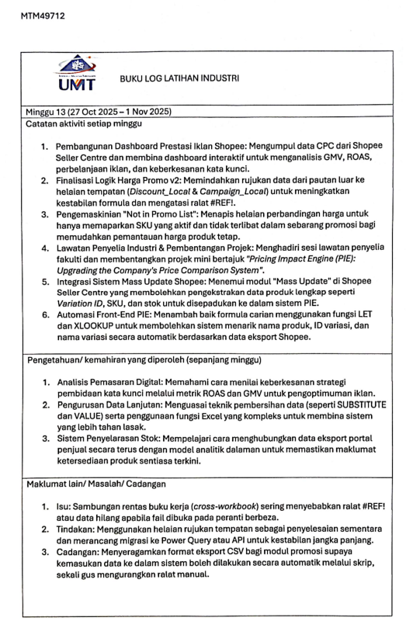

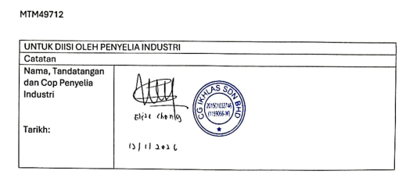

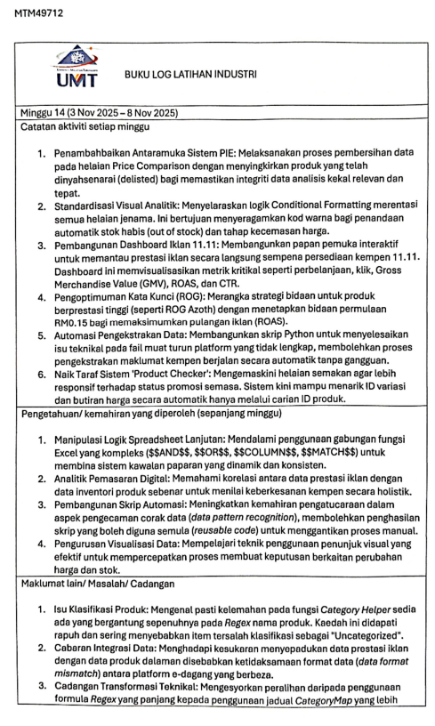

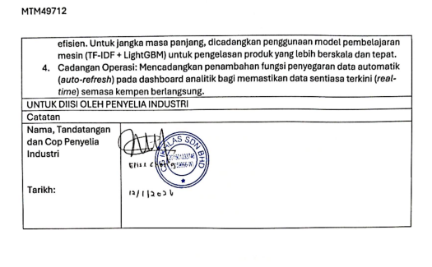

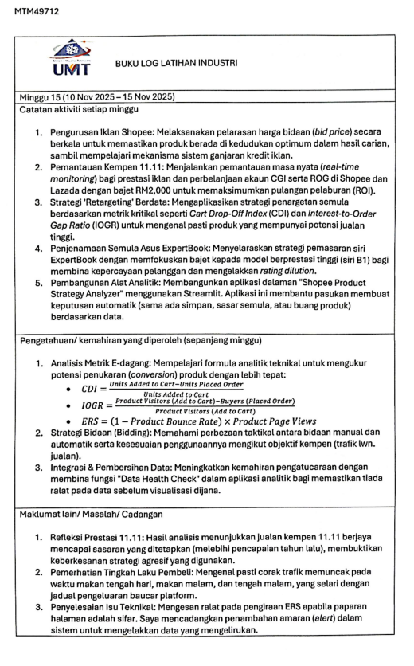
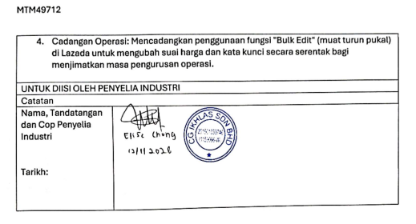

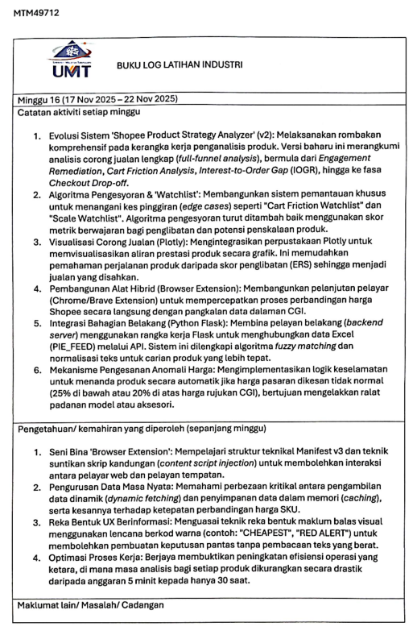

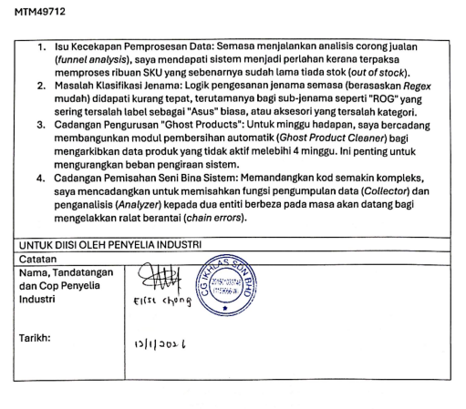

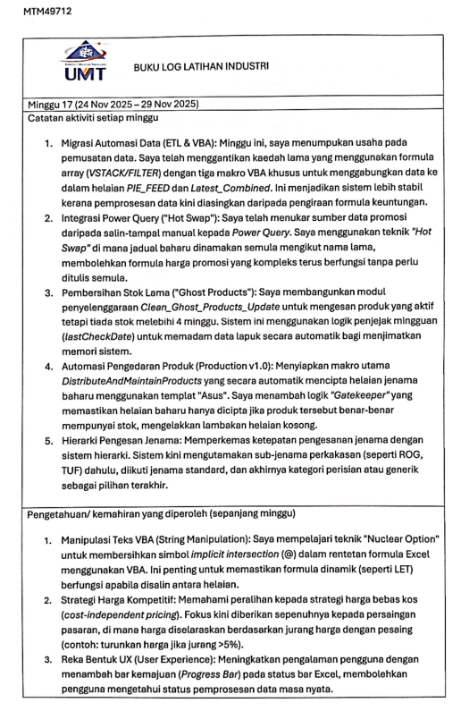

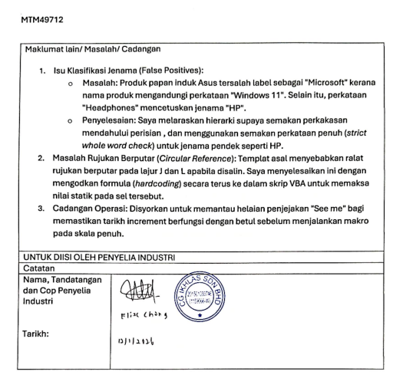

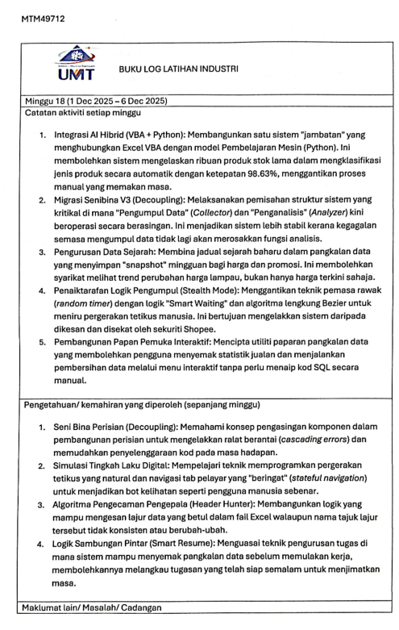

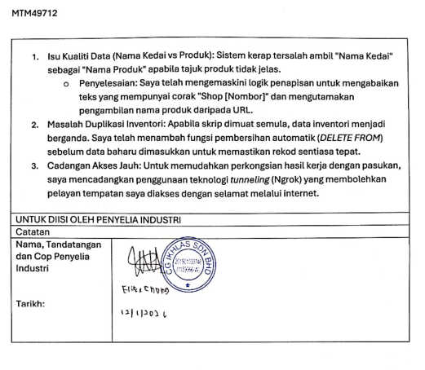

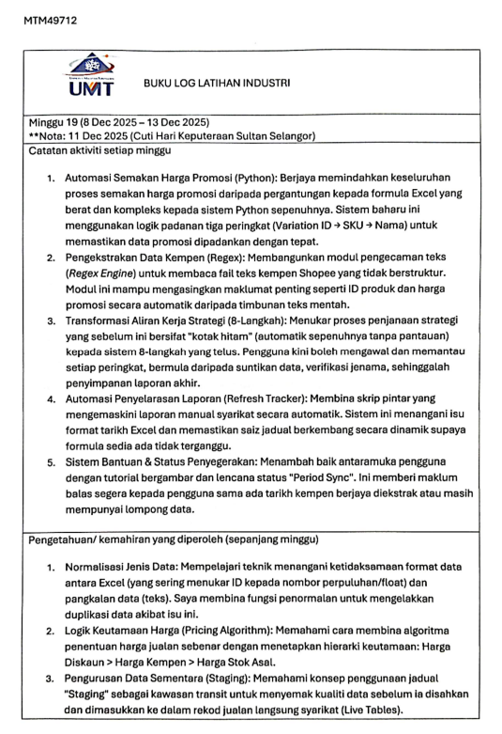

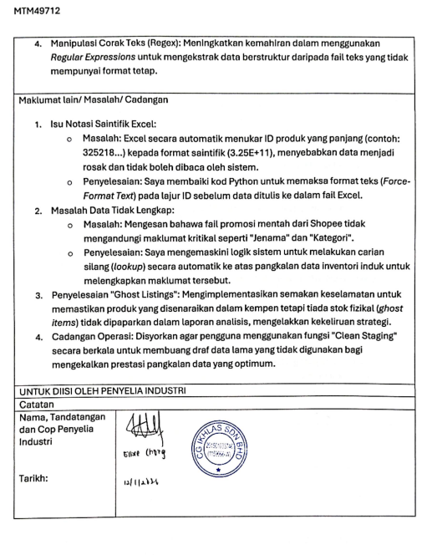

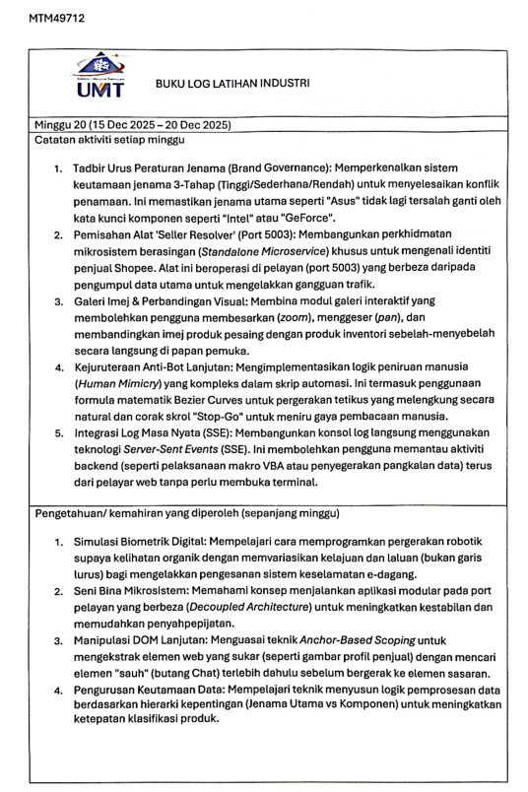

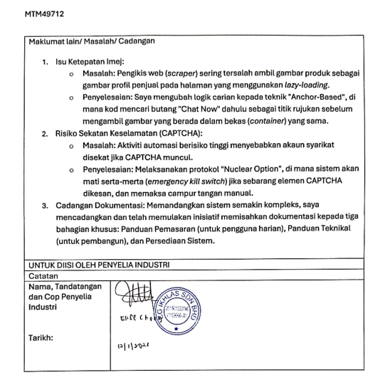

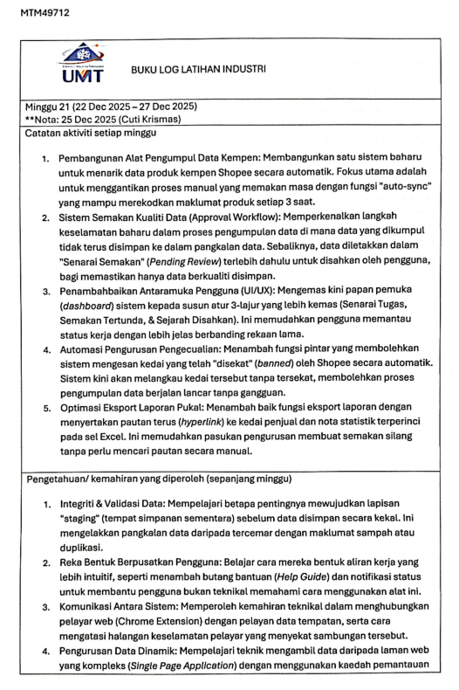

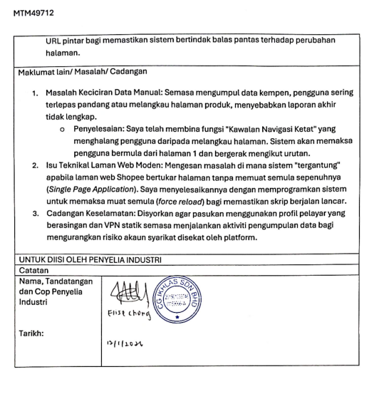

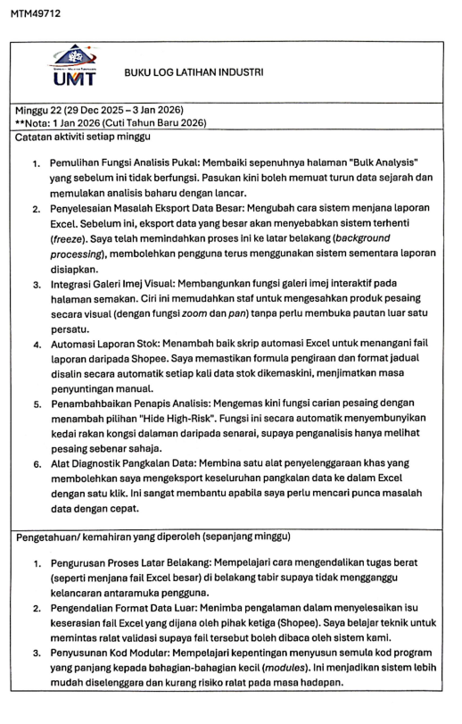

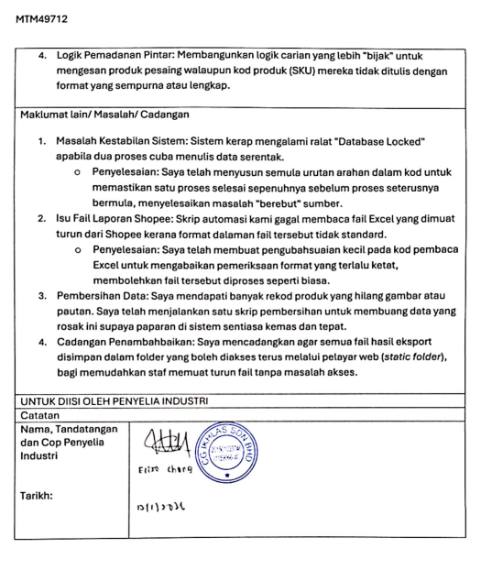

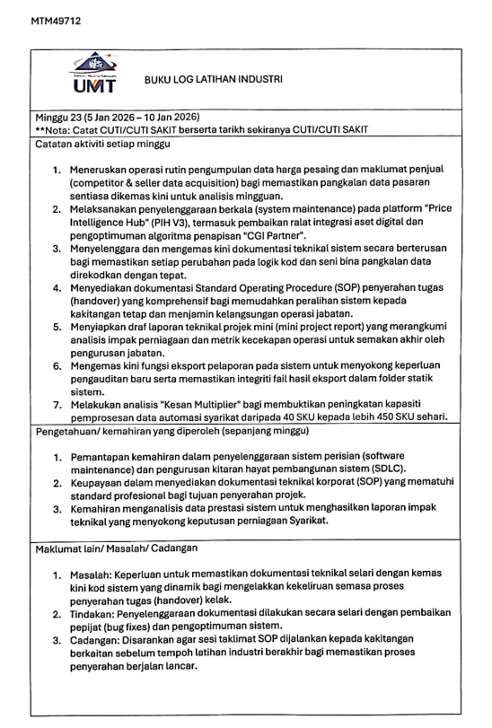

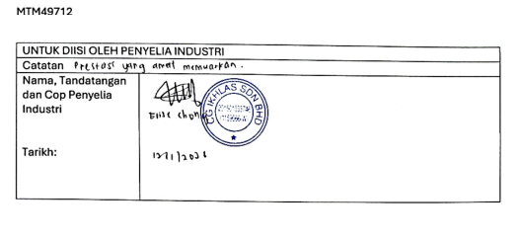

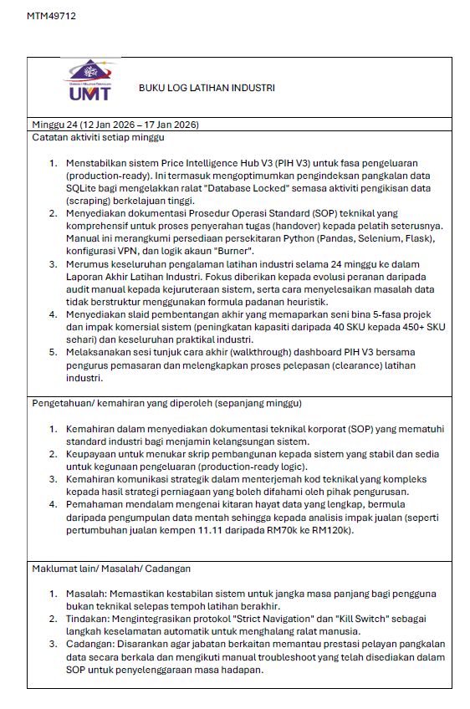


BIODATA OF THE AUTHOR


Name | : Lai Chun Kit
Nationality | : Malaysian
Permanent Address | : No.50, Jalan Bernam 10, Taman Bernam Baru, 35900 Tanjong Malim, Perak
Telephone Number | : 017-5142980
Email | : vaniepersie@gmail.com
Education | : Bachelor of Science in Financial Mathematics with Honours
Award(s)/ Achievements | : RASIO 9.0 Data Science Competition 3rd Place  RASIO 10.0 Data Science Competition Finalist  UMT Innovation 2024 Silver Medal (NomSim: Financial Unity Game)  SRD UMT 2025 Finalist Top 72  Anugerah Dekan, Semester 1 - 6

